**GE2335 Business Programming with Spreadsheet**

***Group Project Report - Team D***

Application Design - Boutique: Casual Charm

**Written by:**

| **Name** | **Student ID** |
| --- | --- |
| **Ng Chun Kit (Kyle)** | **56003469** |
| **Lam Kin Hei (Jerry)** | **56618753** |
| **Fung King Shun (Sam)** | **56659723** |
| **Chan Ka Long (Ivan)** | **56661269** |
| **Chan Ka Ki (Claire)** | **56667643** |
| **Limbu Shreesti** | **57140093** |

**Table of Contents**

**1.** **Introduction 3**

1.1 Product Overview 3

**2.** **Index Page** 4

2.1 Index Page 4

**3.** **User Panel** **5**

3.1 Product List 5

3.1.1 Advanced Search 6

3.1.2 Advanced Search with Error Handler 9

3.1.3 Product List Page Management 10

3.2 Product Details Info 12

3.2.1 Product Pick-Up Error Handler 14

3.3 Shopping Cart 16

3.3.1 Shopping Cart Error Handler 17

3.4 Checkout Info Collection 19

3.4.1 Checkout Data Collection Error Handler 20

3.4.2 Dynamic Excel Database Updated 26

3.5 Receipt 28

3.5.1 Receipt Printing 29

**4****. Admin Panel** **30**

4.1 Login Page 30

4.2 Admin Panel Homepage 33

4.3 Inventory Management 35

4.3.1 Add Product…………………………………………………………………………………38

4.3.2 Edit Product………………………………………….………………………...……………41

4.3.3 Delete Product………………………………………………………………………………43

4.4 Orders Management 44

4.4.2 Edit Orders..…………………………………………….……………………...……………48

4.4.3 Delete Orders.……………………………….………………………………………………52

4.5 Reports Management 53

4.5.1 Sales Report…...…………………………………….……………………...,....……………54

4.5.1.1 Sales Data…………………………………………………………………………...54

4.5.1.2 Sales Dashboard…………...………………………………..………………………57

4.5.2 Inventory Report…...………………………………..….……………………...……………60

4.5.2.1 List All………………………………………………………………………….…..60

4.5.2.2 Quantity Report…………………………………………………………………..…60

4.5.2.3 Category Report………………………………………………………………...…..61

4.5.3 Profit and Loss Report………………..…………………………………………………….61

4.6 Settings 62

# Introduction

## **1.1 Overview**

The purpose of this instruction manual is to help you navigate your way through our application ‘Casual Charm’, an online boutique store intended for both customers and administrators to access separately. There are a total of 12 listed features - 5 for users, 6 for admins, and one Index Page.



Figure 1.1a. Store Logo

# 

# 

# 

# Index Page

## **2.1 Index Page**



Figure 2.1a. Index Page

The index page of the application is for choosing the role of the user. On the index page, users need to pick between ‘NORMAL USER’ (a consumer) and ‘ADMIN USER’ (a staff member).

# User Panel

## **3.1 Product List**

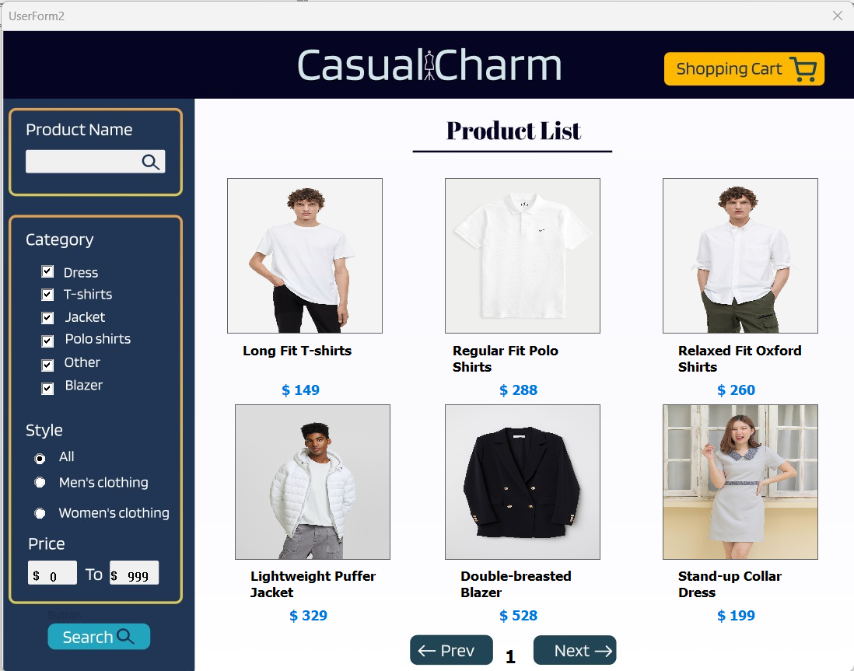

Figure 3.1a. Product List

If the user is a consumer, they will be sent to the ‘Product List’ page where they can view the items available for purchase. If the user already has items in the shopping cart, they can click ‘Shopping Cart’ on the top right to view and update the items in the cart.

### 3.1.1 Advanced Search

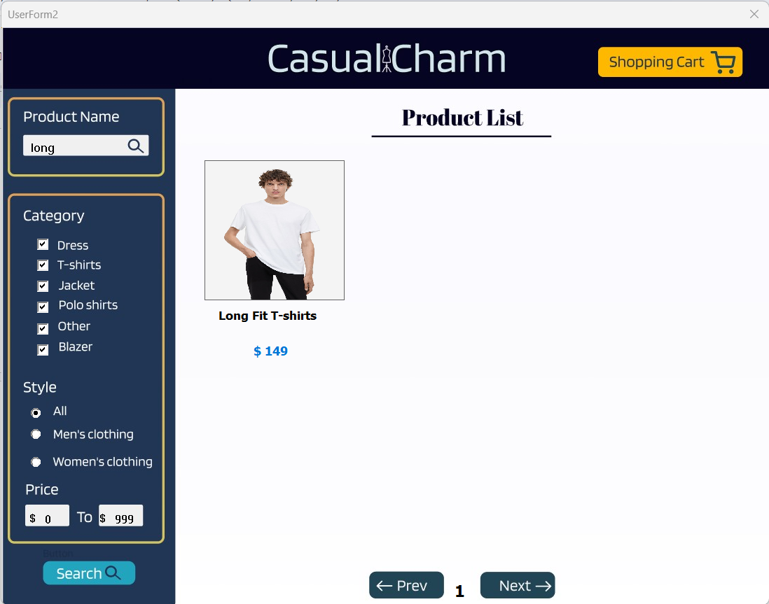

Figure 3.1.1a. Advanced Search by Product Name

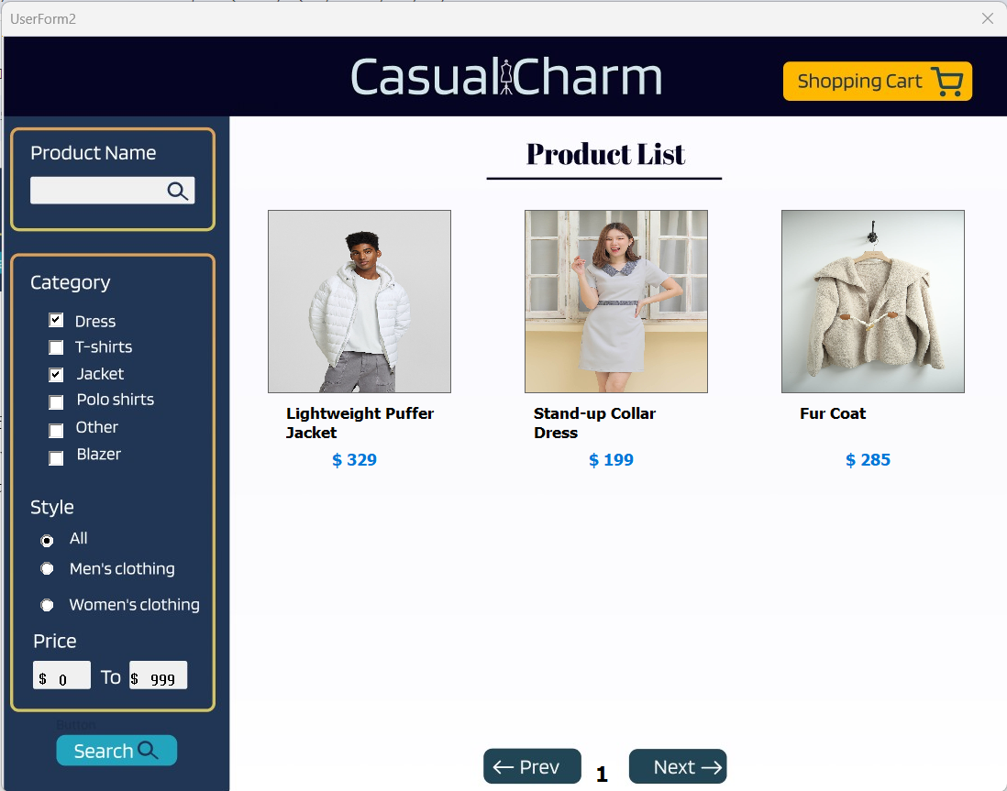

Figure 3.1.1b. Advanced Search by Category Selection

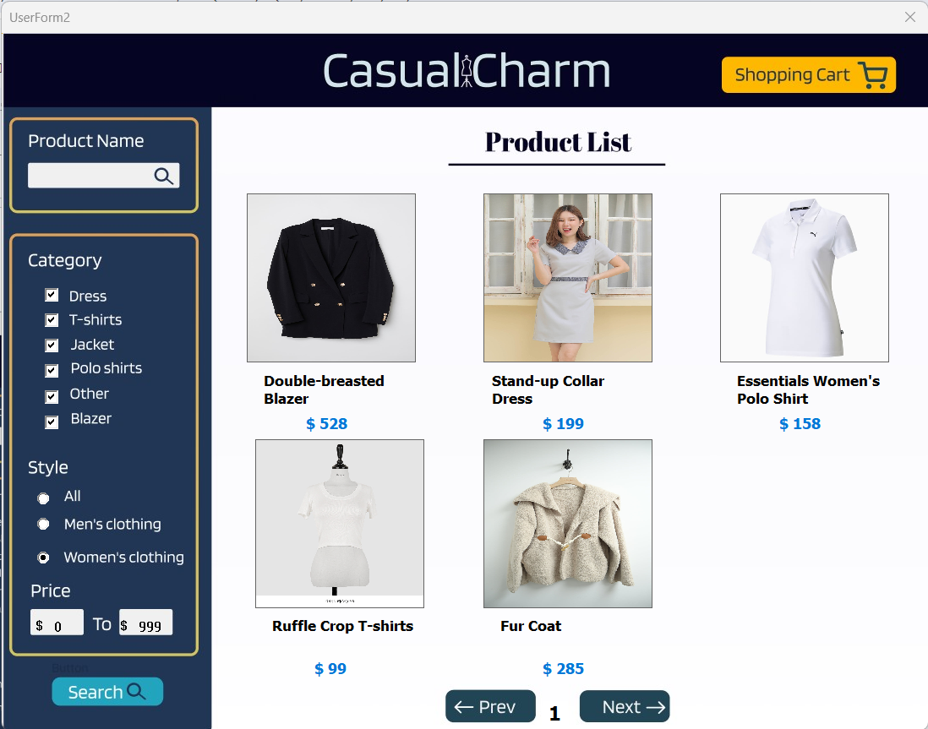

Figure 3.1.1c. Advanced Search by Style Selection

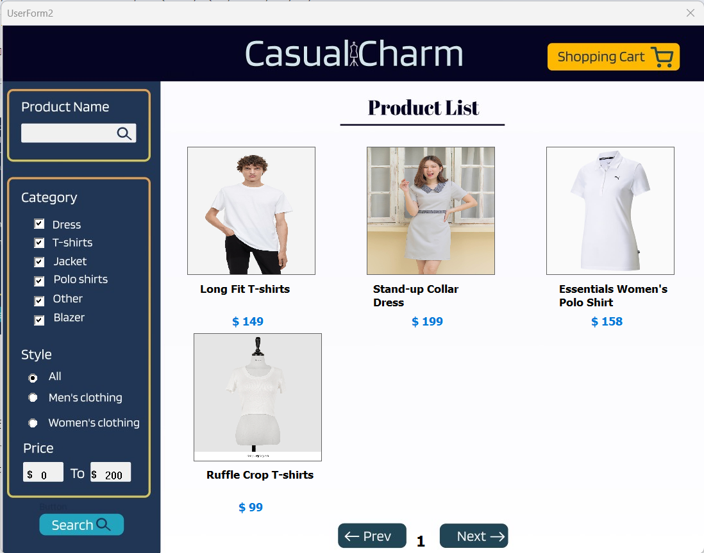

Figure 3.1.1d. Advanced Search by Product Price

On the left is an advanced search. Users looking for specific items can type and search. If the customer wants to adjust the product list, they can go to the ‘Category’, ‘Style’, and ‘Price’ sections, then click the ‘Search’ button below

### 3.1.2 Advanced Search with Error Handler

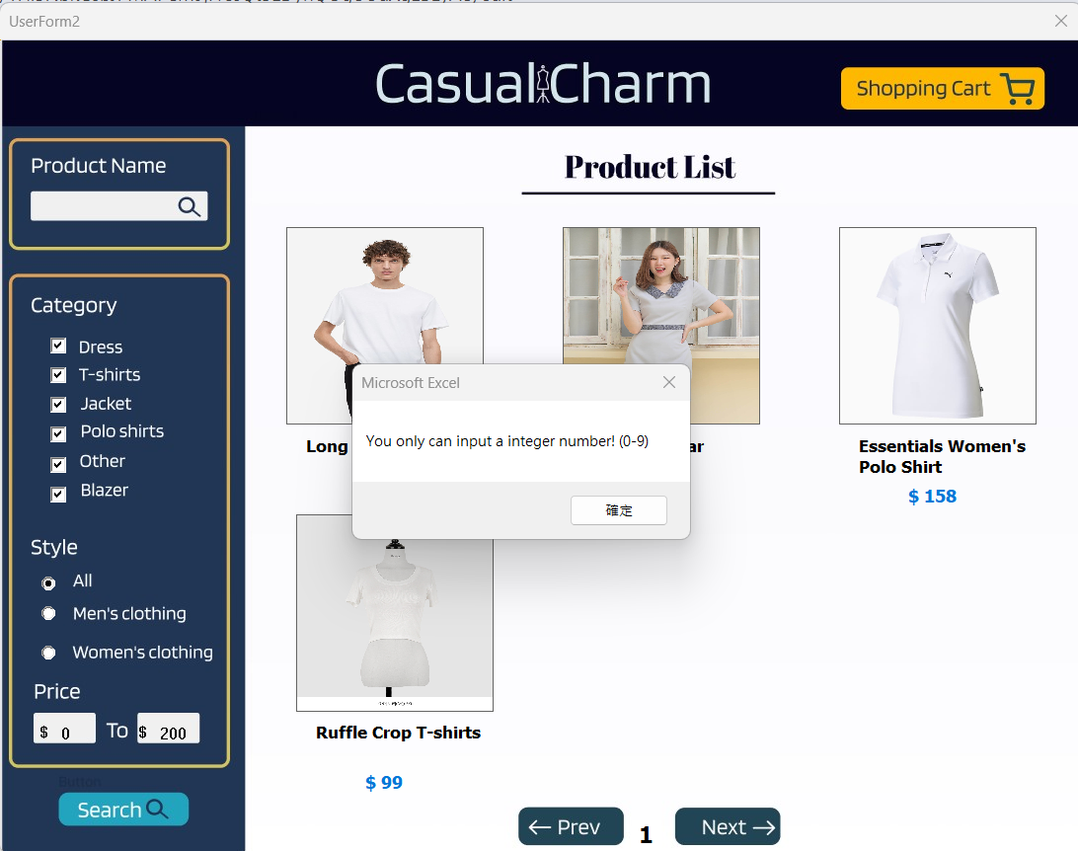

Figure 3.1.2a. Advanced Search by Product Price Trigger Typing Error

If the user enters an invalid character that is not a number, it will be an invalid input. The program will automatically reset the textbox to make it blank. It will ask for user input again, until the User enters valid numbers. The Program also limits the maximum number that can be entered to 3 digits 0-999.

### 3.1.3 Product List Page Management

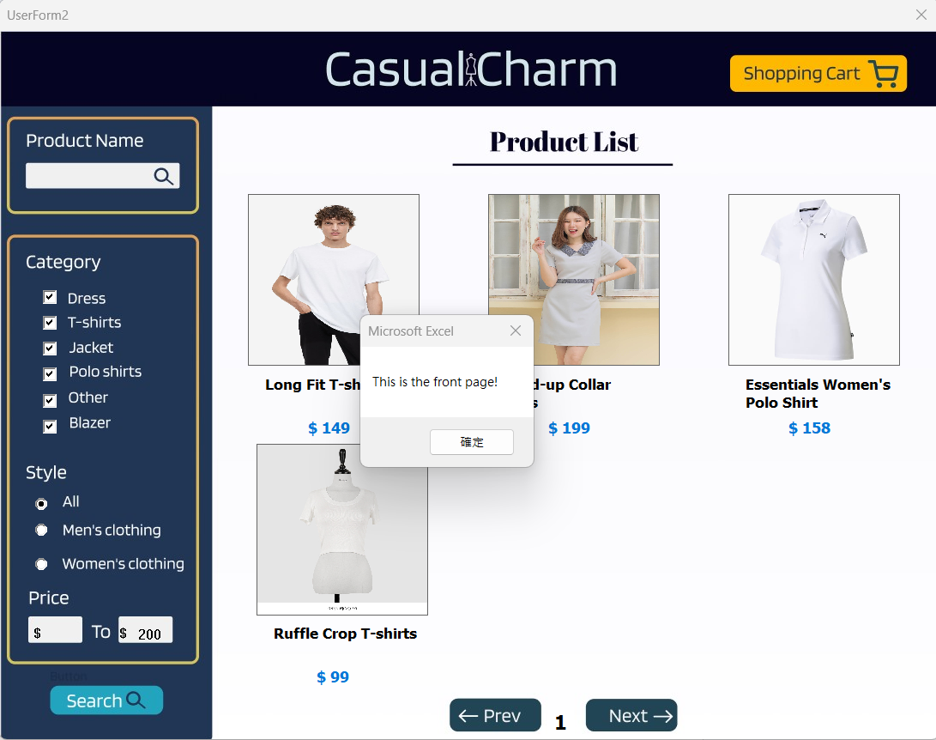

Figure 3.1.3a. Page Message Box on Front Page

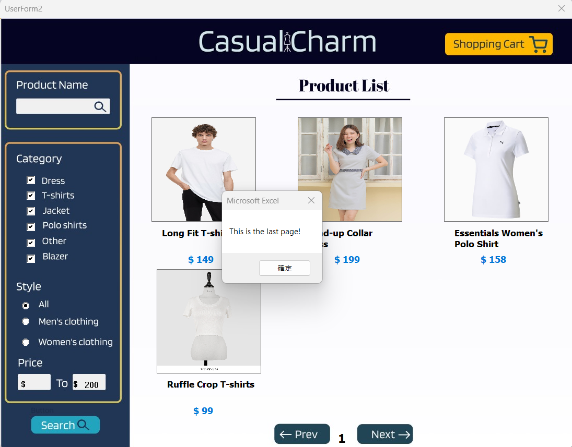

Figure 3.1.3b. Page Message Box on Last Page

Given that they are not interested in the first few selections, the user can click ‘Next’ at the bottom of the page until they are satisfied with a product. On the assumption that the customer is already on the last or first page and presses ‘Next’ or ‘Prev’ respectively, a message box will pop up informing them it is already on the first or last page

## **3.2 Product Details Info**

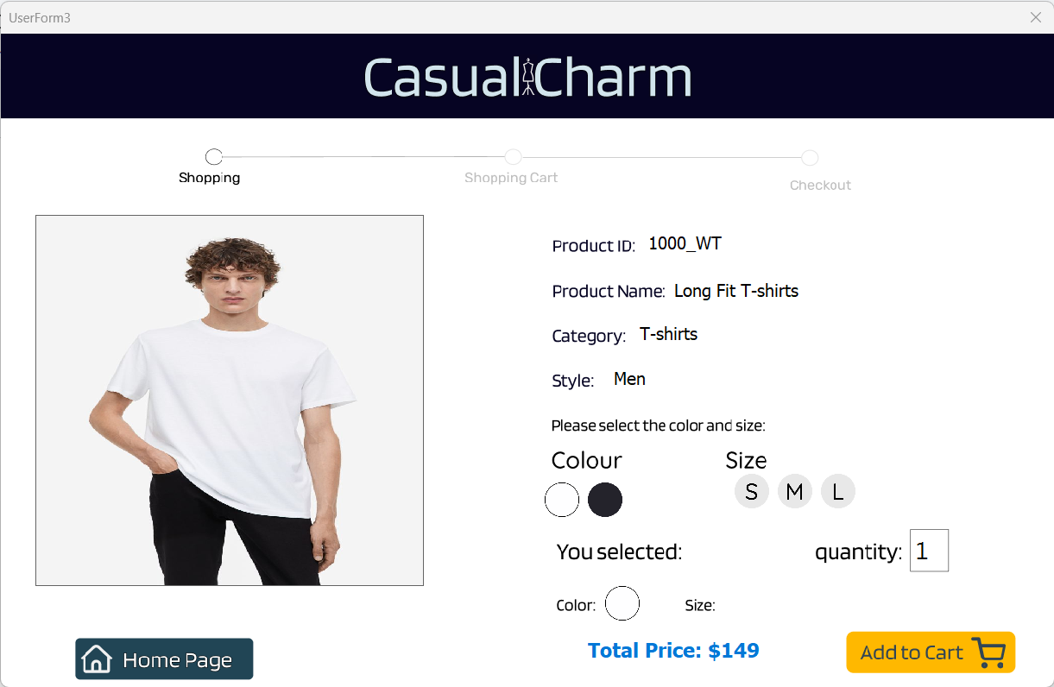

Figure 3.2a. Product Info

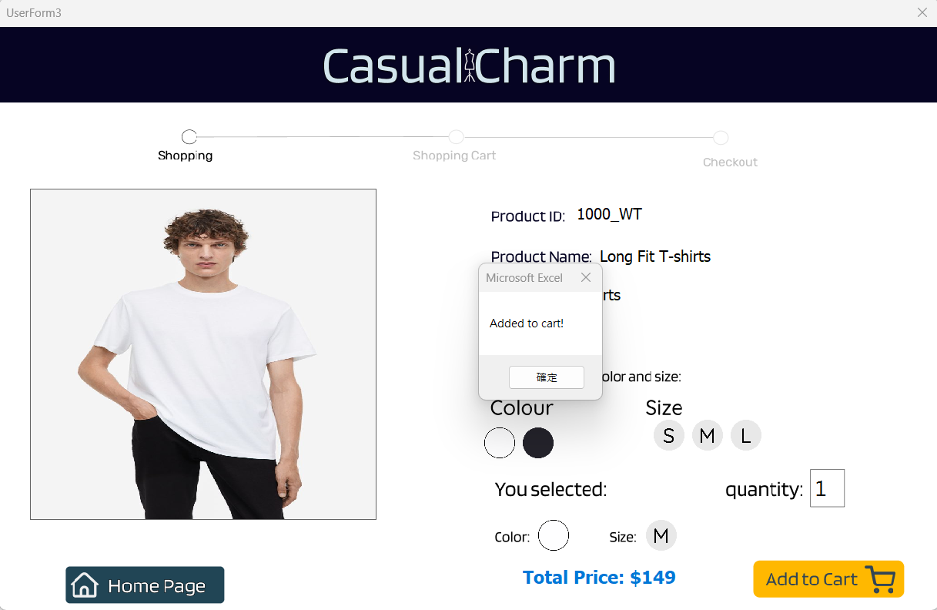

Figure 3.2b. Successfully Pick-up A Product

After clicking a product’s image in the Product List, the user will be sent to the ‘Product Details’ page. In this page, consumers can select the color, size, and quantity of the clothing item by clicking the buttons. By changing the quantity textbox, the blue color text total price will auto-update and calculate the price. Presuming that the customer decides to disregard the current product, they can click the ‘Home Page’ button on the bottom left to continue browsing the selections.

### 3.2.1 Product Pick-Up Error Handler

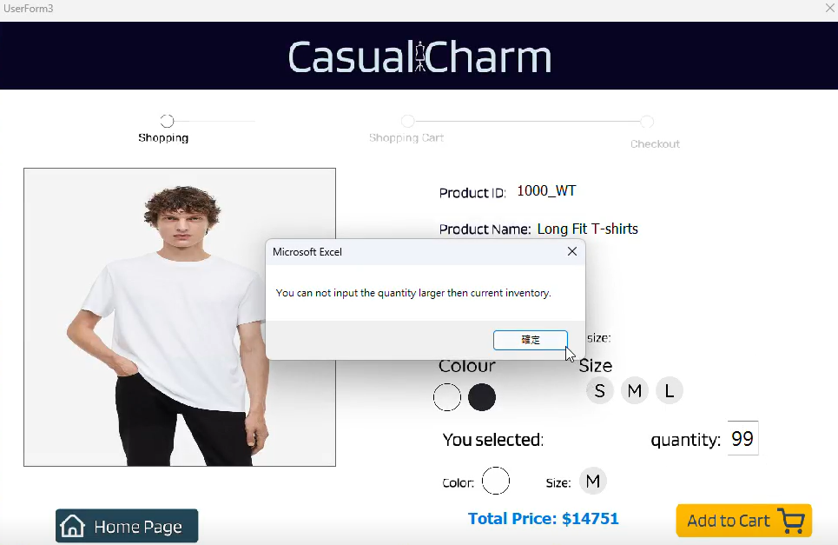

Figure 3.2.1a. Inventory Error Check

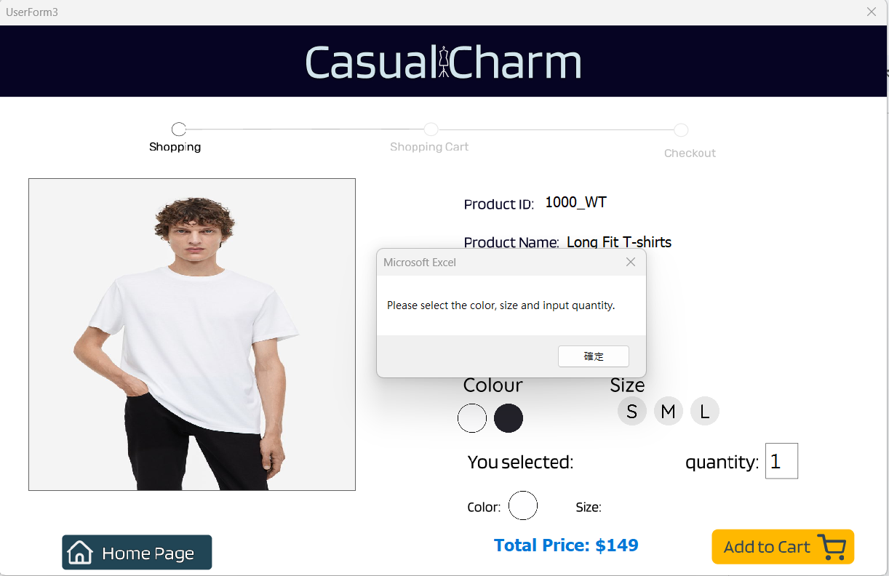

Figure 3.2.1b. Color, Size and Quantity Error Check

* Inventory Error Check

In the event that the inputted quantity number is higher than the amount in the inventory, a message box will appear informing the user of the problem. Once all conditions are fulfilled, users can simply ‘Add to Cart’ to proceed with the purchase.

* Color, Size and Quantity Error Check

If users haven’t selected and inputted the Color, Size or Quantity information, a message box will appear requesting the selections. Once all conditions are fulfilled, users can simply ‘Add to Cart’ to proceed with the purchase

## **3.3 Shopping Cart**

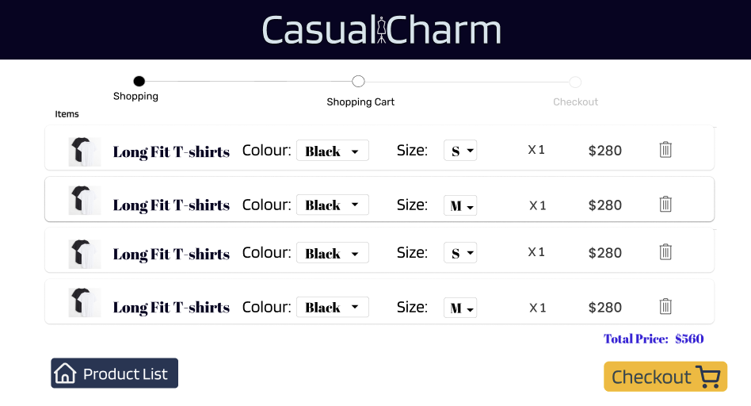

Figure 3.3a. Shopping Cart Page

Customers can access the shopping cart in two ways: By clicking ‘Shopping Cart’ on the ‘Product List’ page and clicking ‘Add to Cart’ from the ‘Product Details’ page. In the shopping cart, users can adjust the color and size of the items in the cart. If they change their mind about an item and want another one, they can click the trash icon at the end of the row and then click ‘Product List’. Once the customer is satisfied with the items, they can select ‘Checkout’.

### *3.*3.1 *Shopping Cart Error Handler*

Figure 3.3.1a. Shopping Cart with No Item

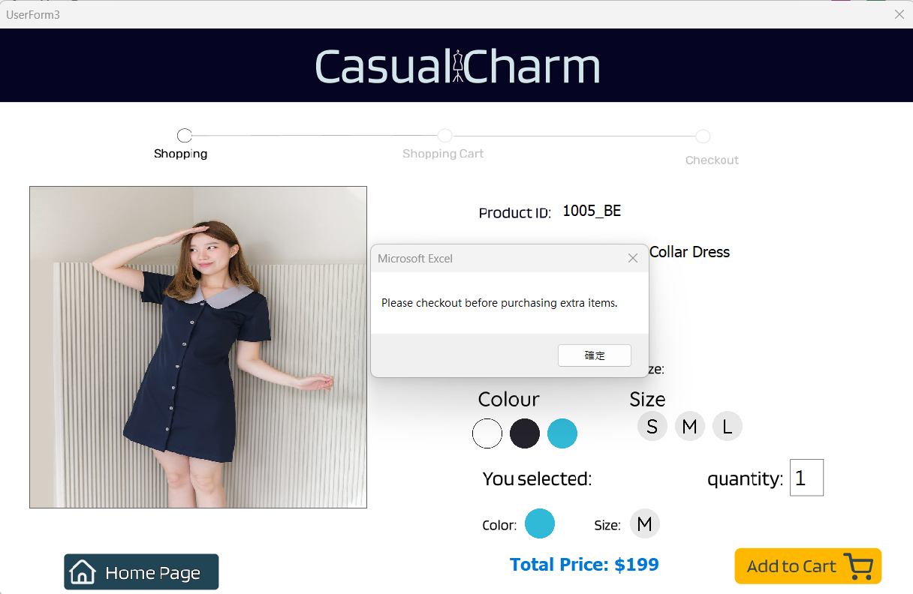

Figure 3.3.1b. Shopping Cart Items More Than Four

* Shopping Cart with No Item

If the user clicks the checkout button, but the shopping cart is currently empty. The program will reject the current process and be unable to the next step. It requires users to click the "Product List" button to add at least one item to the shopping cart for the checkout.

* Shopping Cart Items More Than Four

The program limits the purchase of a maximum of 4 items in one order. If the current number of shopping cart items is 4. Then the user can not add other products to the cart. The user must check out the current order first. Then create a second order to buy the remaining product

## **3.4 Checkout Info Collection**

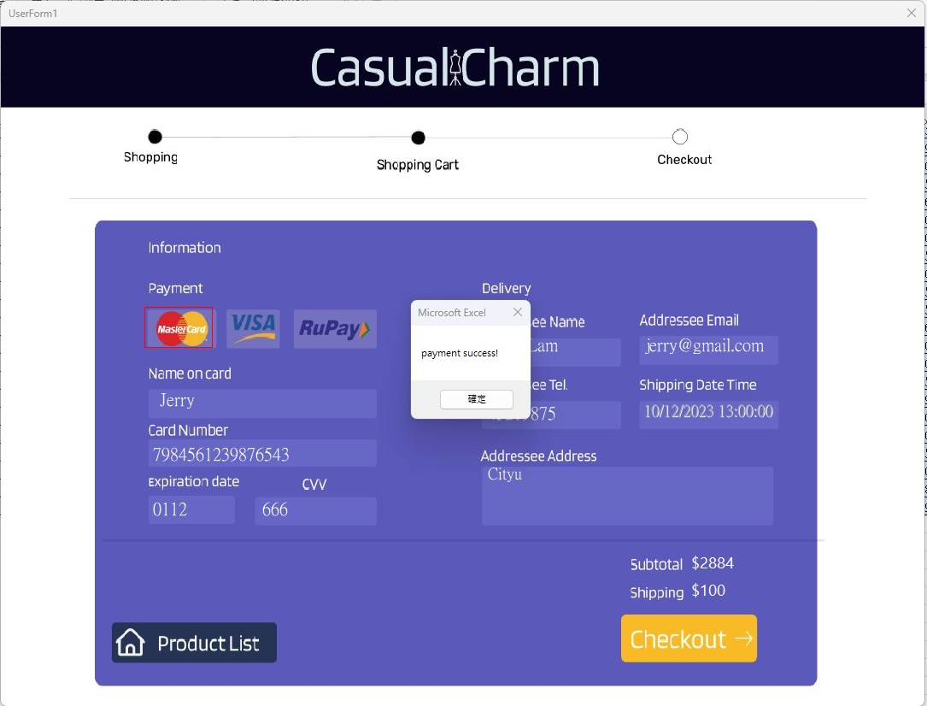

Figure 3.4a Checkout Page

On the ‘Checkout’ page, the customer will need to fill in their personal information. When the name, card number, expiration date, CVV, delivery address, email, and phone number are all filled in, the customer can press ‘Checkout’ to successfully complete the payment. In case the user wants to further add more to the shopping cart, they can click ‘Product List’. After the user input all fields on the checkout page, the payment is successfully achieved. The default shipping Data Time will be 8 working days after the payment and there will be a shipping cost of $100. As a result, both the subtotal cost and shipping cost will be deducted from the user account. If the user does not fill in all the boxes and select the method of payment, a message box will appear telling the user.

### 3.4.1 Checkout Data Collection Error Handler

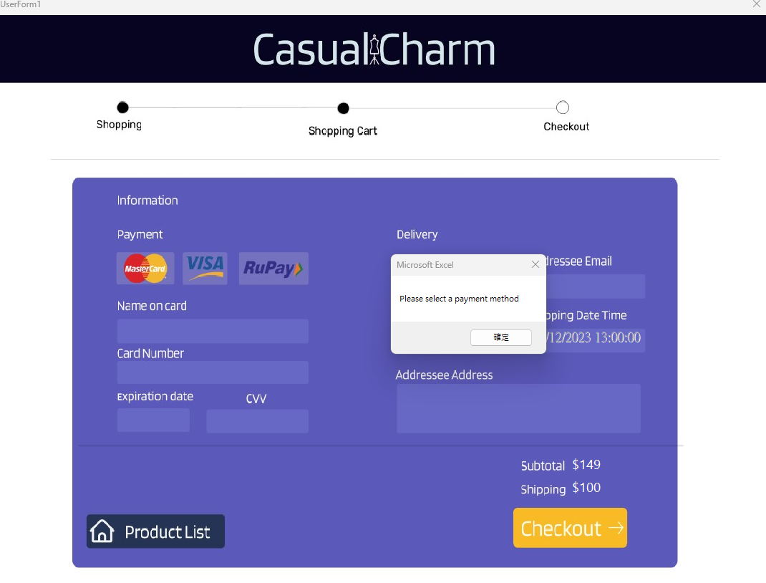

Figure 3.4.1a Invalid Payment Method Error Check

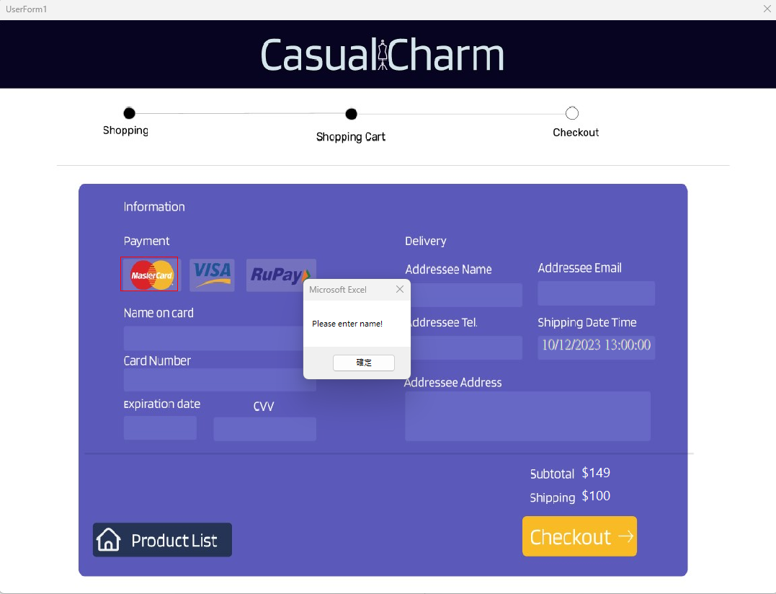

Figure 3.4.1b Invalid Card Name Error Check

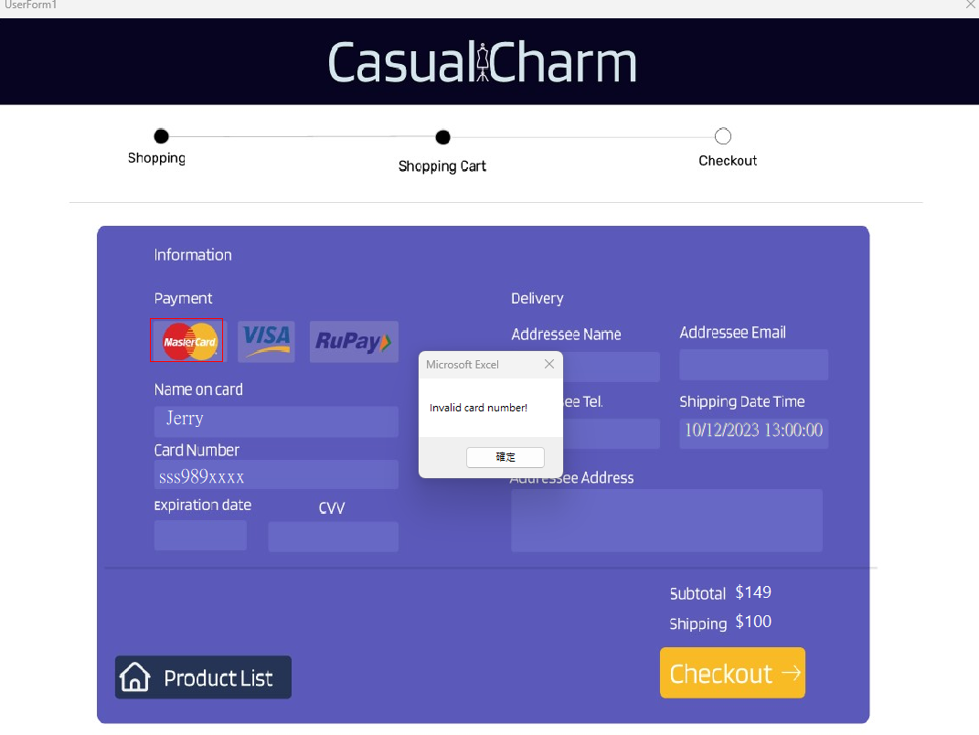

Figure 3.4.1c Invalid Card Number Error Check

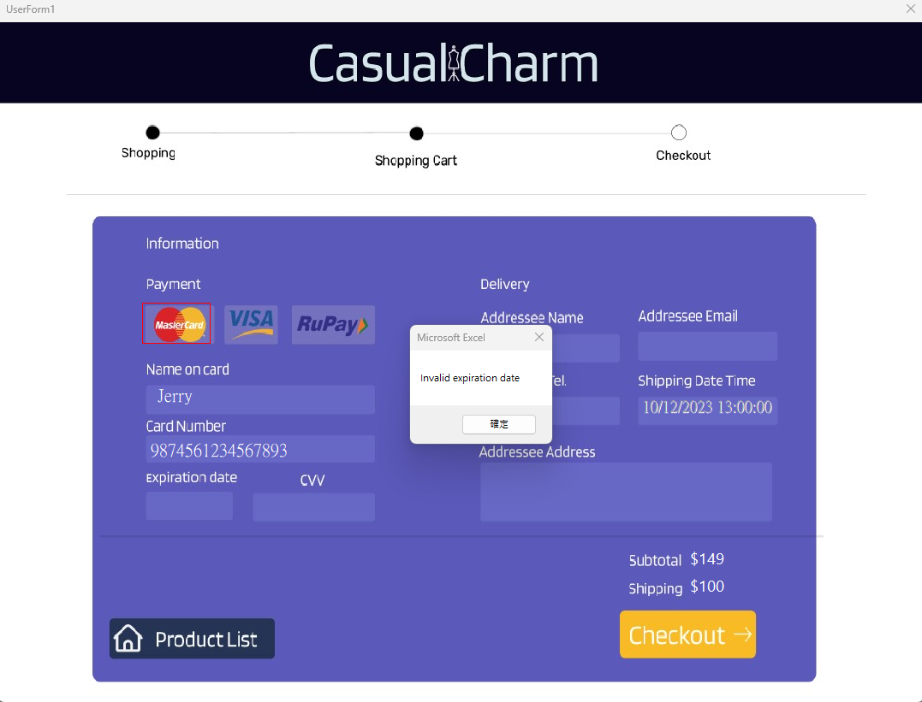

Figure 3.4.1d Invalid Expiration Date Error Check

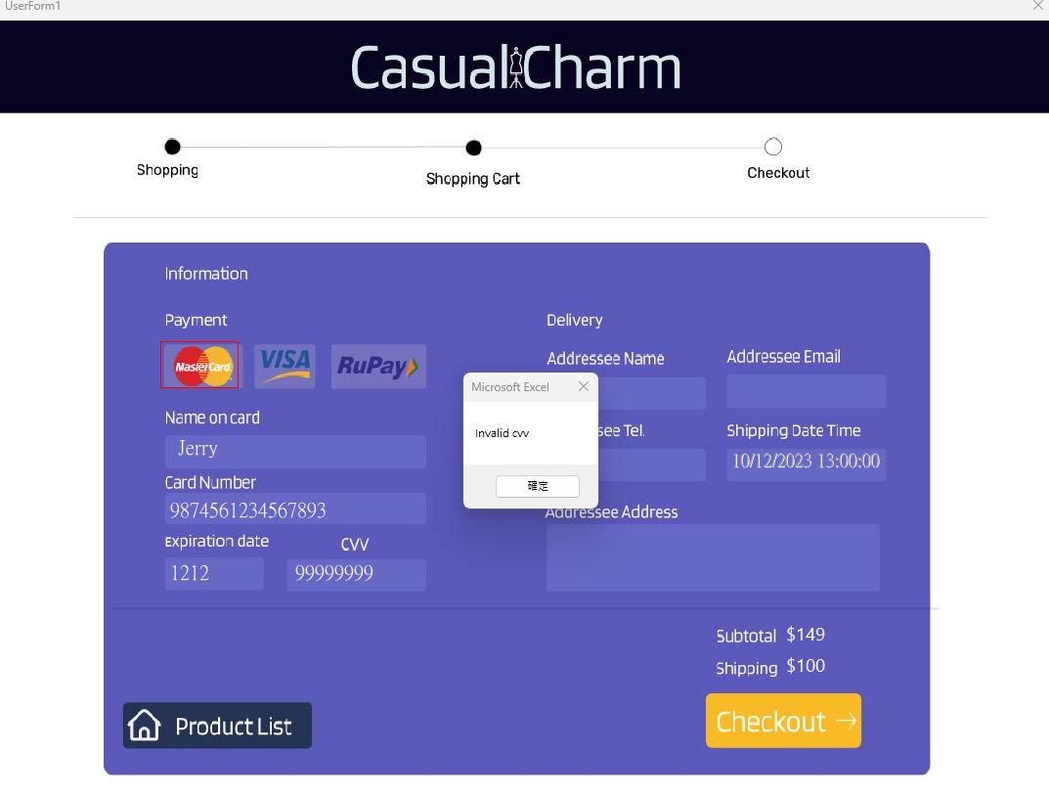

Figure 3.4.1e Invalid CVV Error Check

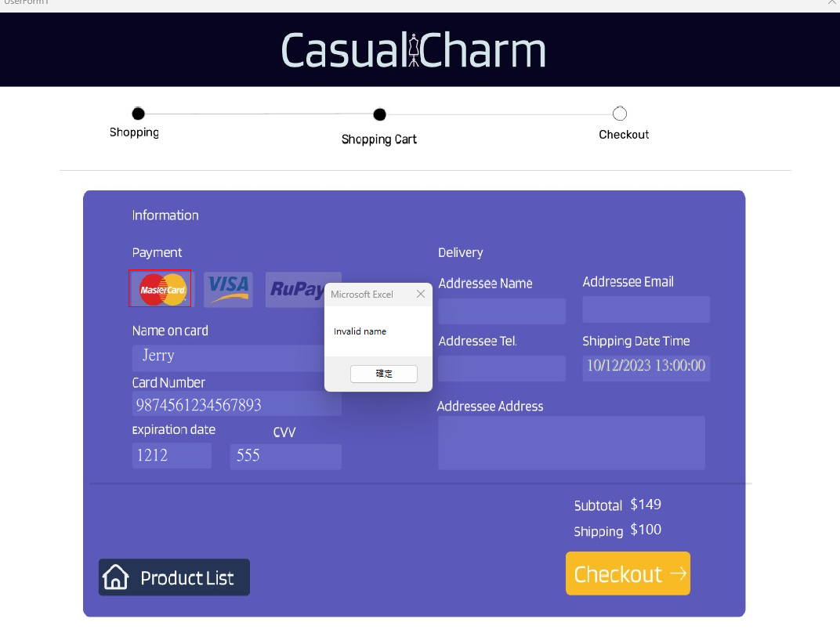

Figure 3.4.1f Invalid Addressee Name Error Check

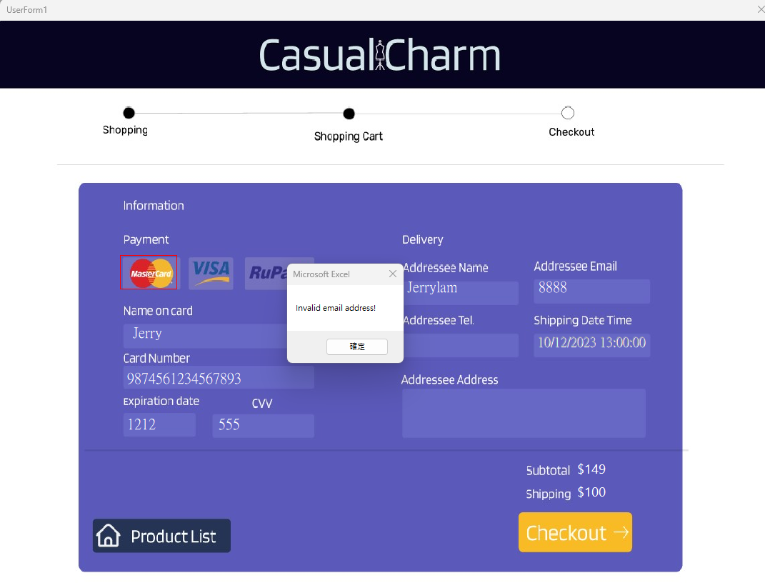

Figure 3.4.1g Invalid Email Address Error Check

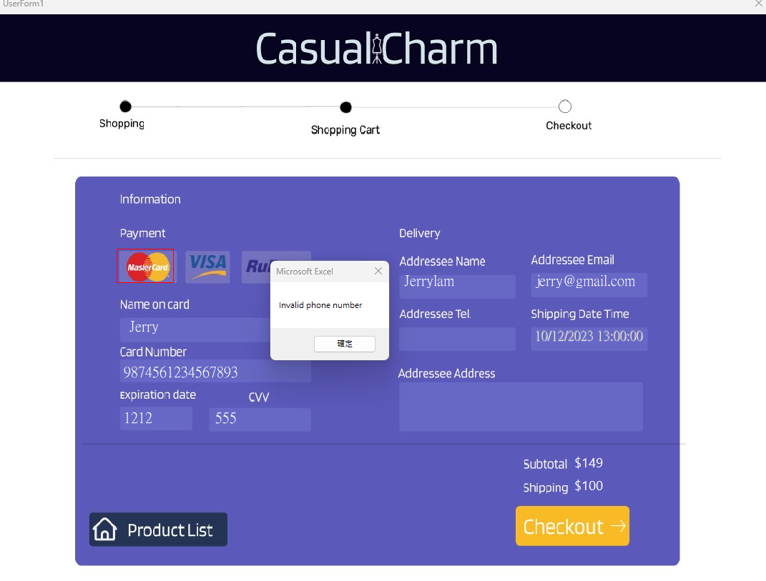

Figure 3.4.1h Invalid Phone number Error Check

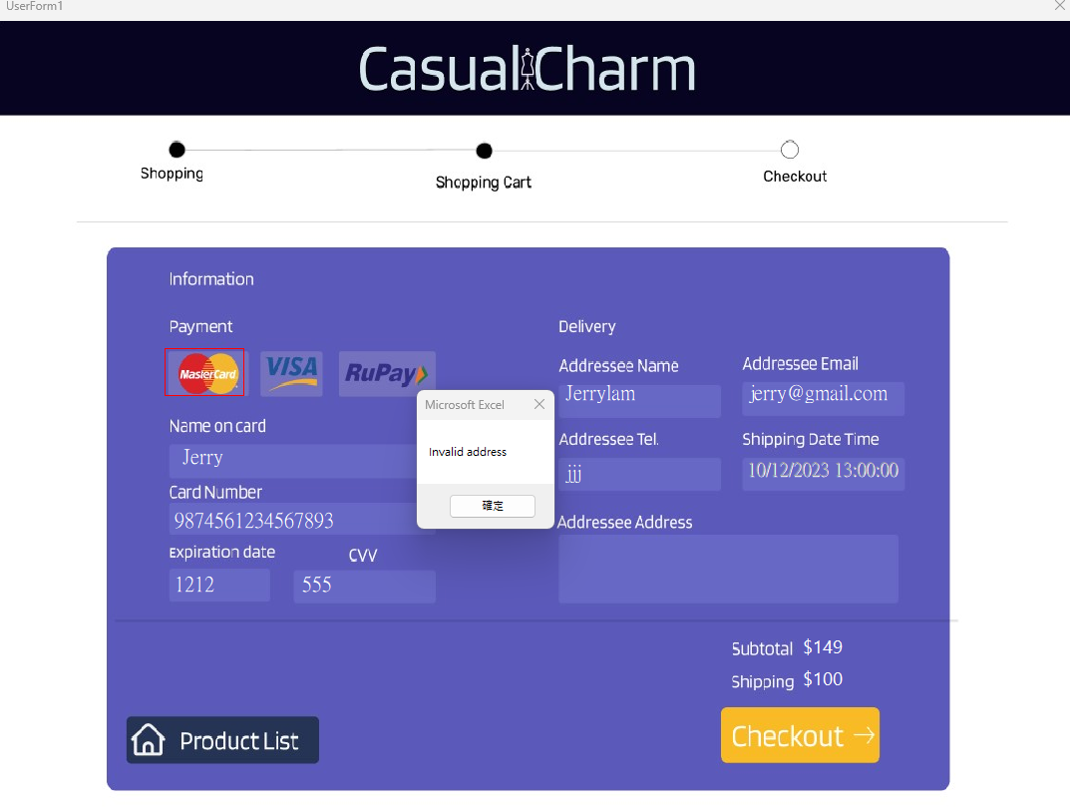

Figure 3.4.1i Invalid Address Error Check

* Invalid Payment Method Error Check

The user needs to select one kind of method. If not, a message box will appear if the information is invalid.

* Invalid Card Name Error Check

The card name needs to have a valid email to be accepted. A message box will appear if the information is invalid.

* Invalid Card Number Error Check

The card number needs to have a valid email to be accepted. A message box will appear if the information is invalid.

* Invalid Expiration Date Error Check

The expiration date needs to have a valid email to be accepted. A message box will appear if the information is invalid.

* Invalid CVV Error Check

The cvv field needs to have a valid phone number to be accepted. A message box will appear if the information is invalid.

* Invalid Addressee Name Error check

The cvv field needs to have a valid phone number to be accepted. A message box will appear if the information is invalid.

* Invalid Email Address Error check

The email address field needs to have a valid phone number to be accepted. A message box will appear if the information is invalid.

* Invalid Phone number Error check

The phone number field needs to have a valid phone number to be accepted. A message box will appear if the information is invalid.

* Invalid Address Error check

The address field needs to have a valid phone number to be accepted. A message box will appear if the information is invalid.

### 3.4.2 *Dynamic Excel Database Updated*

Figure 2.4.2a Order Customer Sheet

After the checkout function is clicked, the VBA program will add the new data to the database. It will automatically assign a unique customer ID to the record, together with the data input from the checkout page. A new record is successfully added to the order customer sheet.

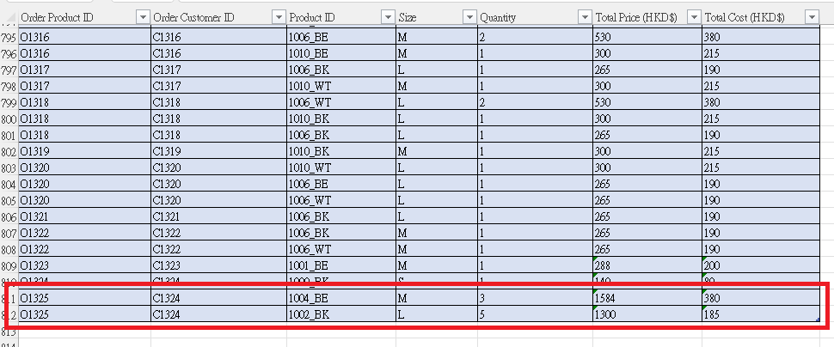

Figure 2.4.2b Order Product Sheet

To ensure better product management, order product sheet will also be updated. Every time a new order is performed. A new order ID will be assigned. If a customer purchases many items in one order, the order and customer ID will still be preserved. Relevant information like product ID, size and quantity will be displayed.

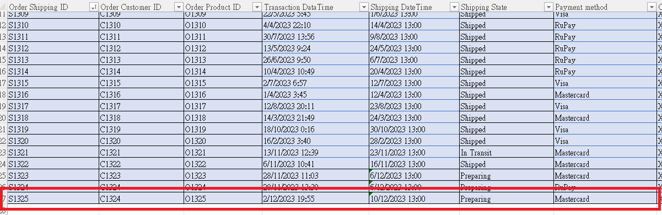

Figure 2.4.2c Order Shipping Sheet

The order shipping sheet will also be updated to record the shipping detail. Once the customer successfully purchases, a new unique shipping ID will be assigned. As shown in the photo, the corresponding Customer ID and product ID will also be recorded to ensure data consistency. When an order is set up, the default shipping state will be prepared, once the shipping is started, it will record at in transit. If the customer successfully purchased the product, it will be shipped. Other information like payment method and credit card number will also be recorded.

## **3.5 Receipt**

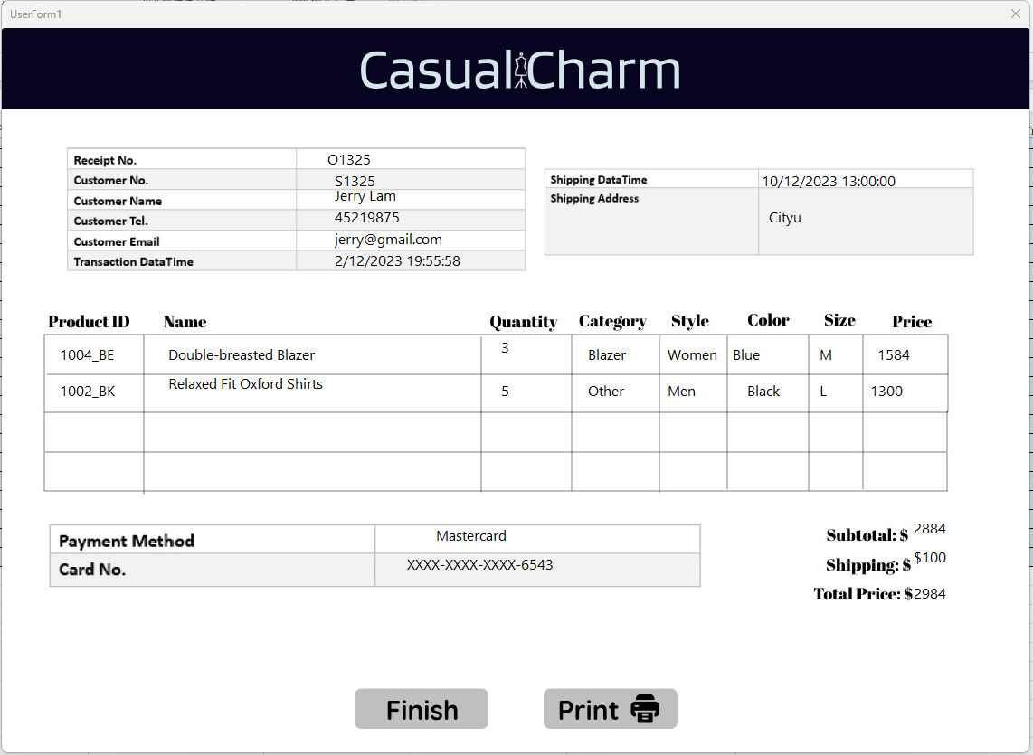

Figure 3.5a Receipt

After payment, the receipt will pop up. The customer can review the bought items as well as the inputted personal information. On the top right is the official shipping date and time for the items. If the user wants to obtain a hard copy of the receipt, they can click ‘Print’. If they do not, they can click ‘Finish’, marking the end of the shopping experience.

### 3*.5.1 Receipt Printing*

Figure 2.I Receipt Printing

After the user clicks the ‘Print’ button, the receipt data will be sent to the default printer, and the user can keep a physical copy of the receipt for future reference.

# 4. Admin Panel

## **4.1 Login Page**

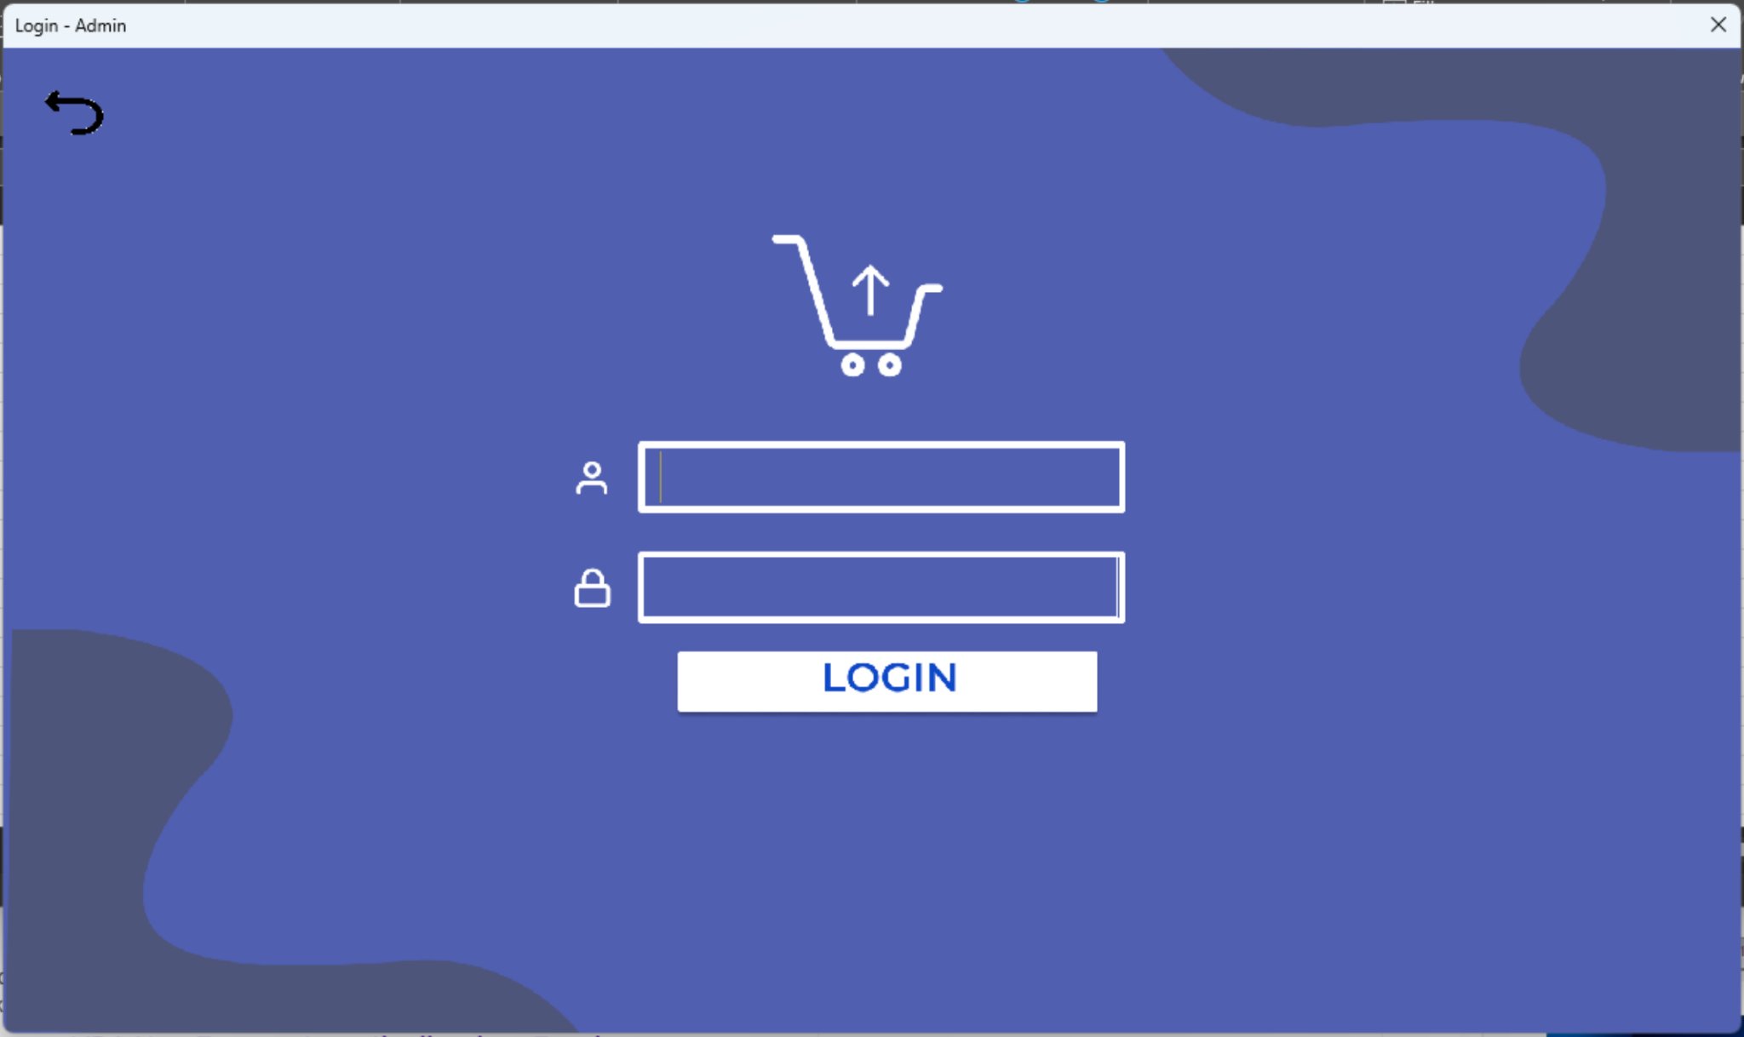

Figure 4.1a Admin User Interface

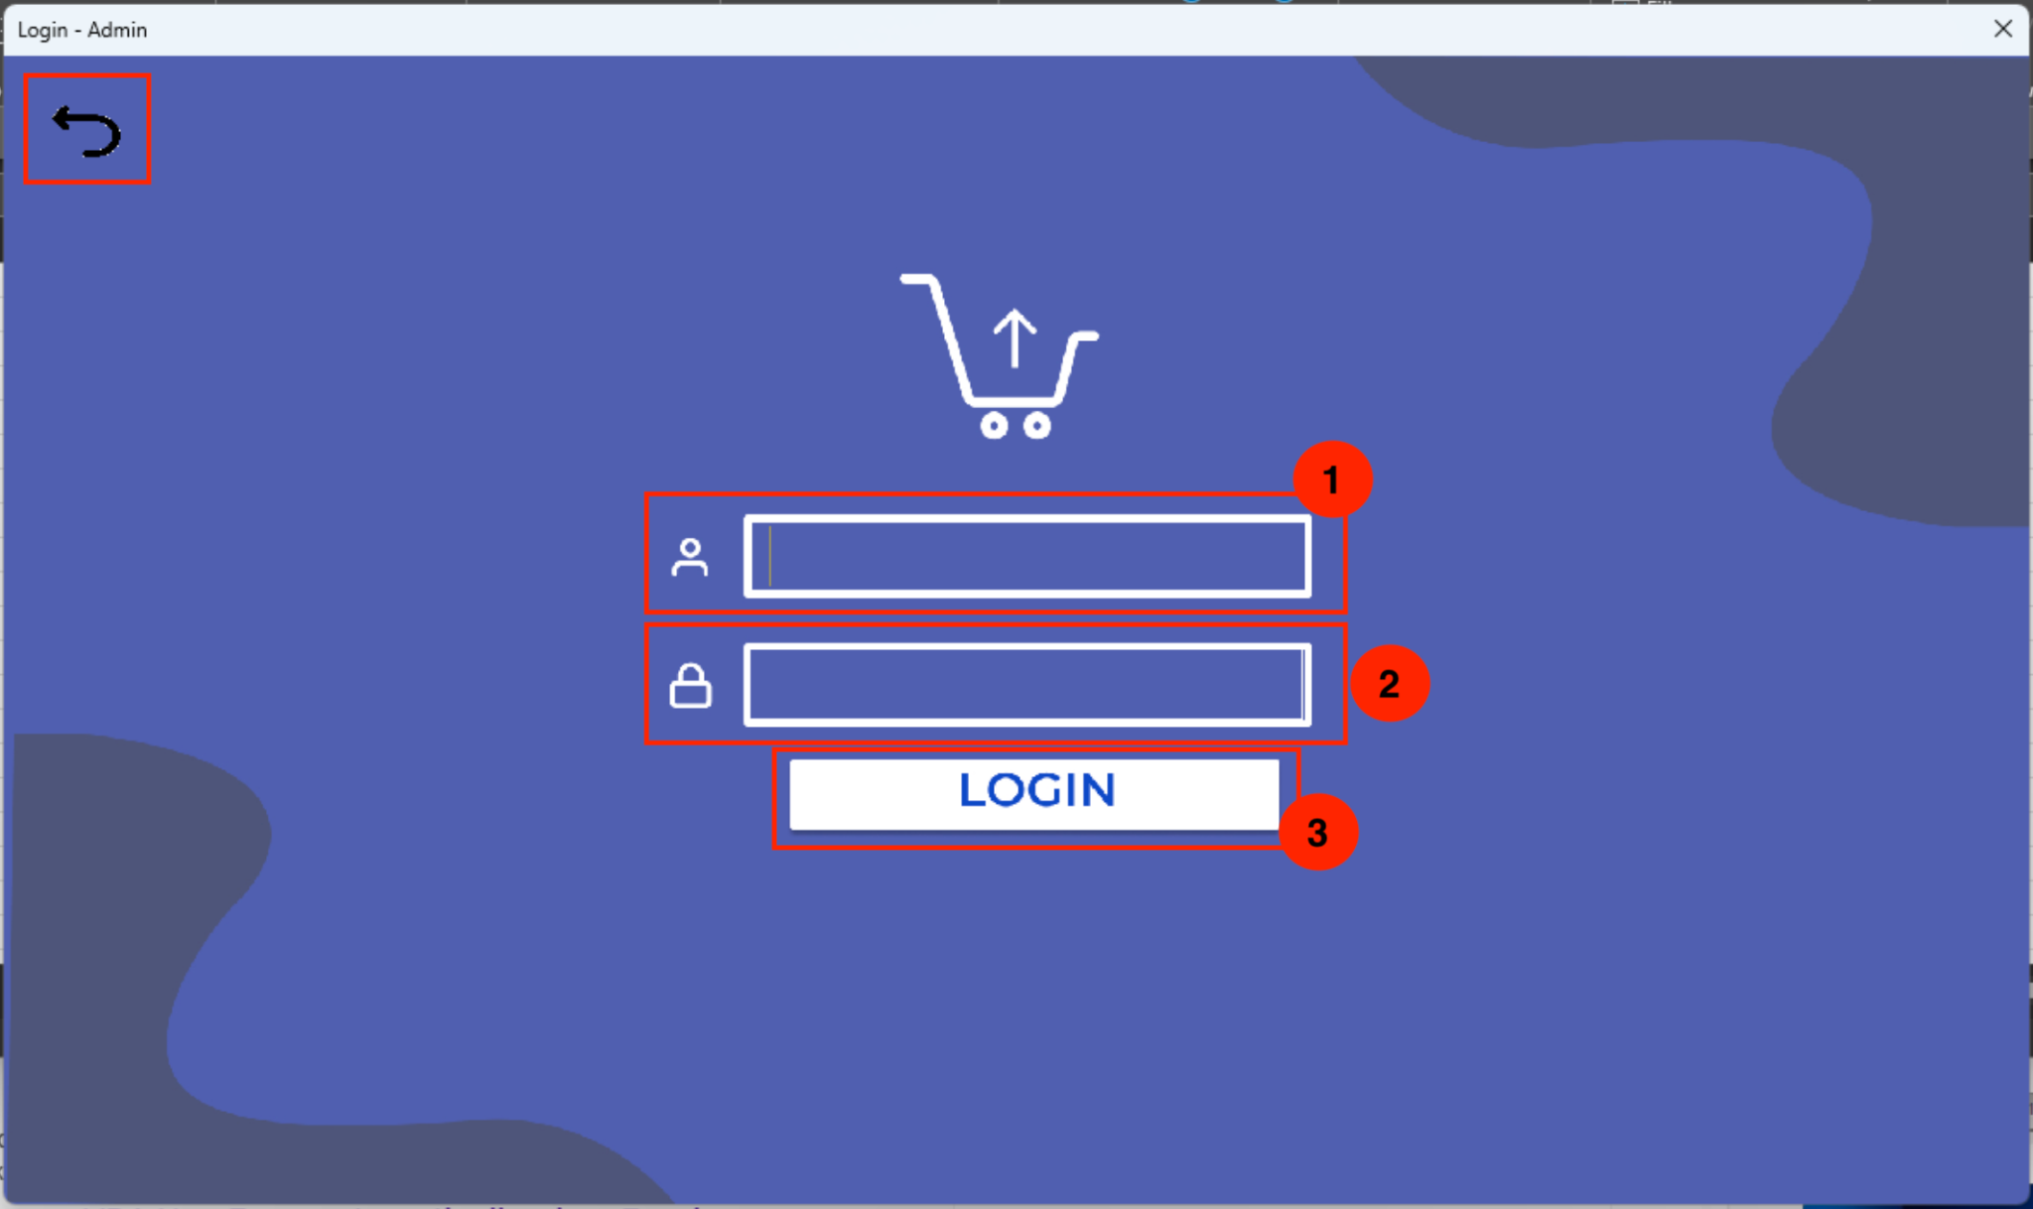

Figure 4.1b Admin Login Page Flow

In the upper left corner is an arrow button that allows the user to go back to the Index Page.

Users need to first enter the username and password. Then click the “LOGIN” button to log in to the admin panel.

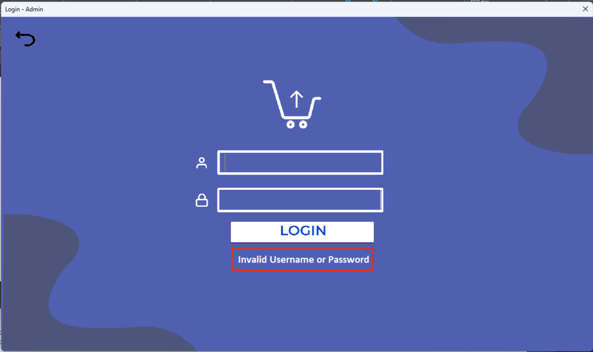

Figure 4.1c Invalid Input

If an invalid username or password is submitted, the error message will appear.

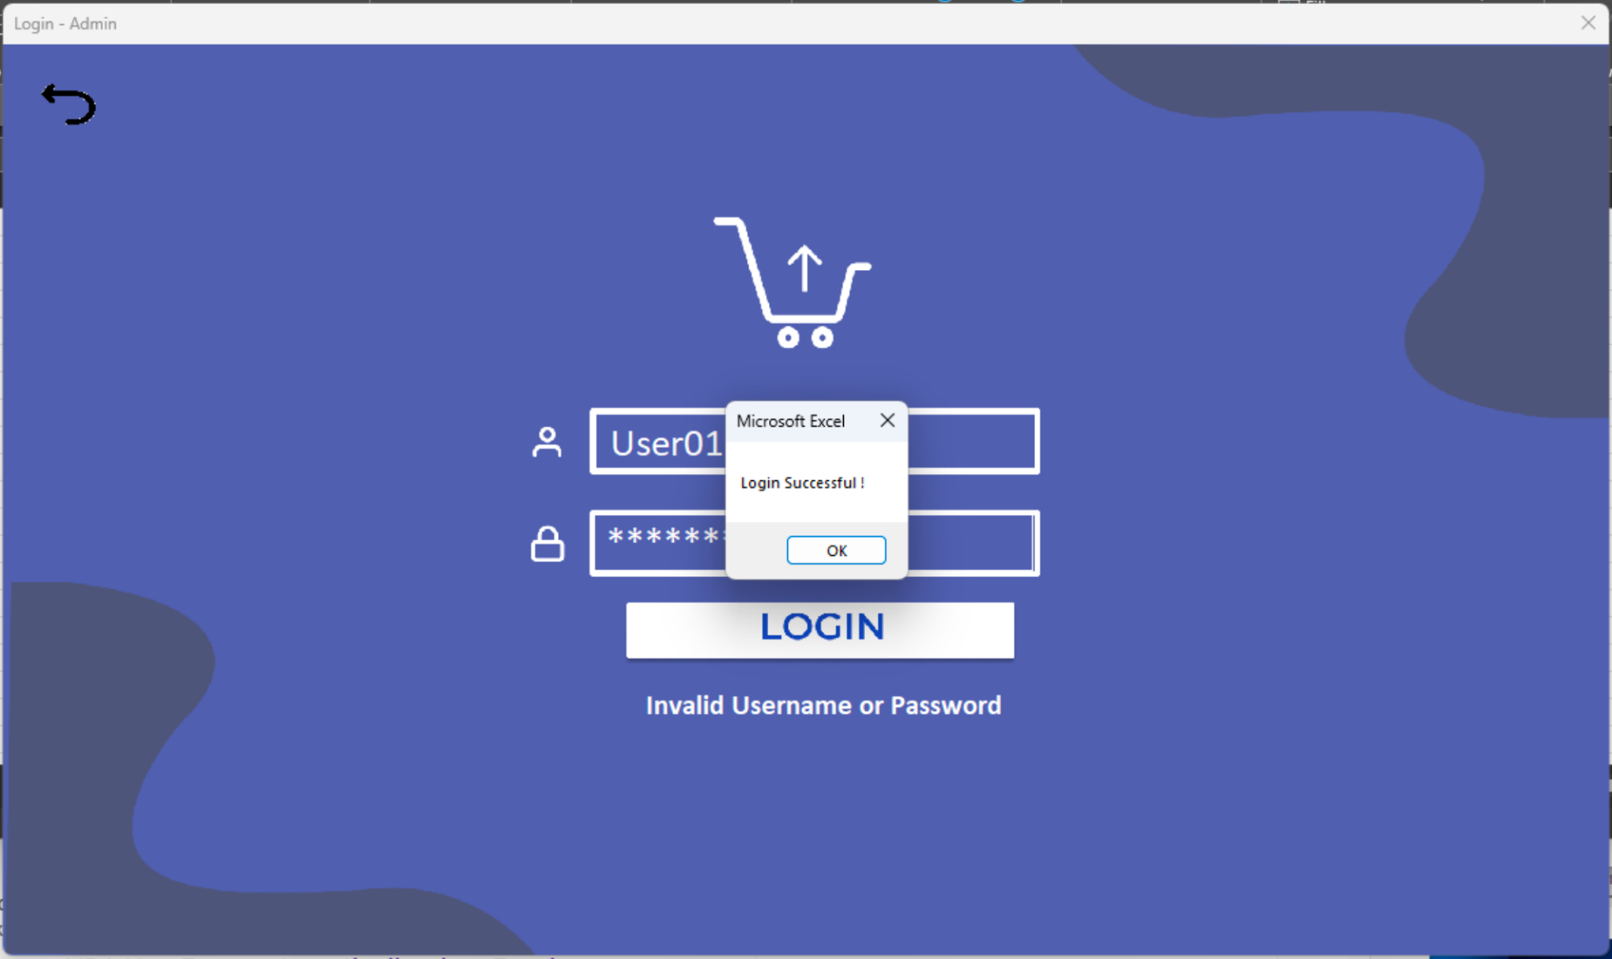

Figure 4.1d Login Successful Message Box

If the correct username and password are submitted, a popup window will appear and indicate that it is a successful login.

## **4.2 Admin Panel Homepage**

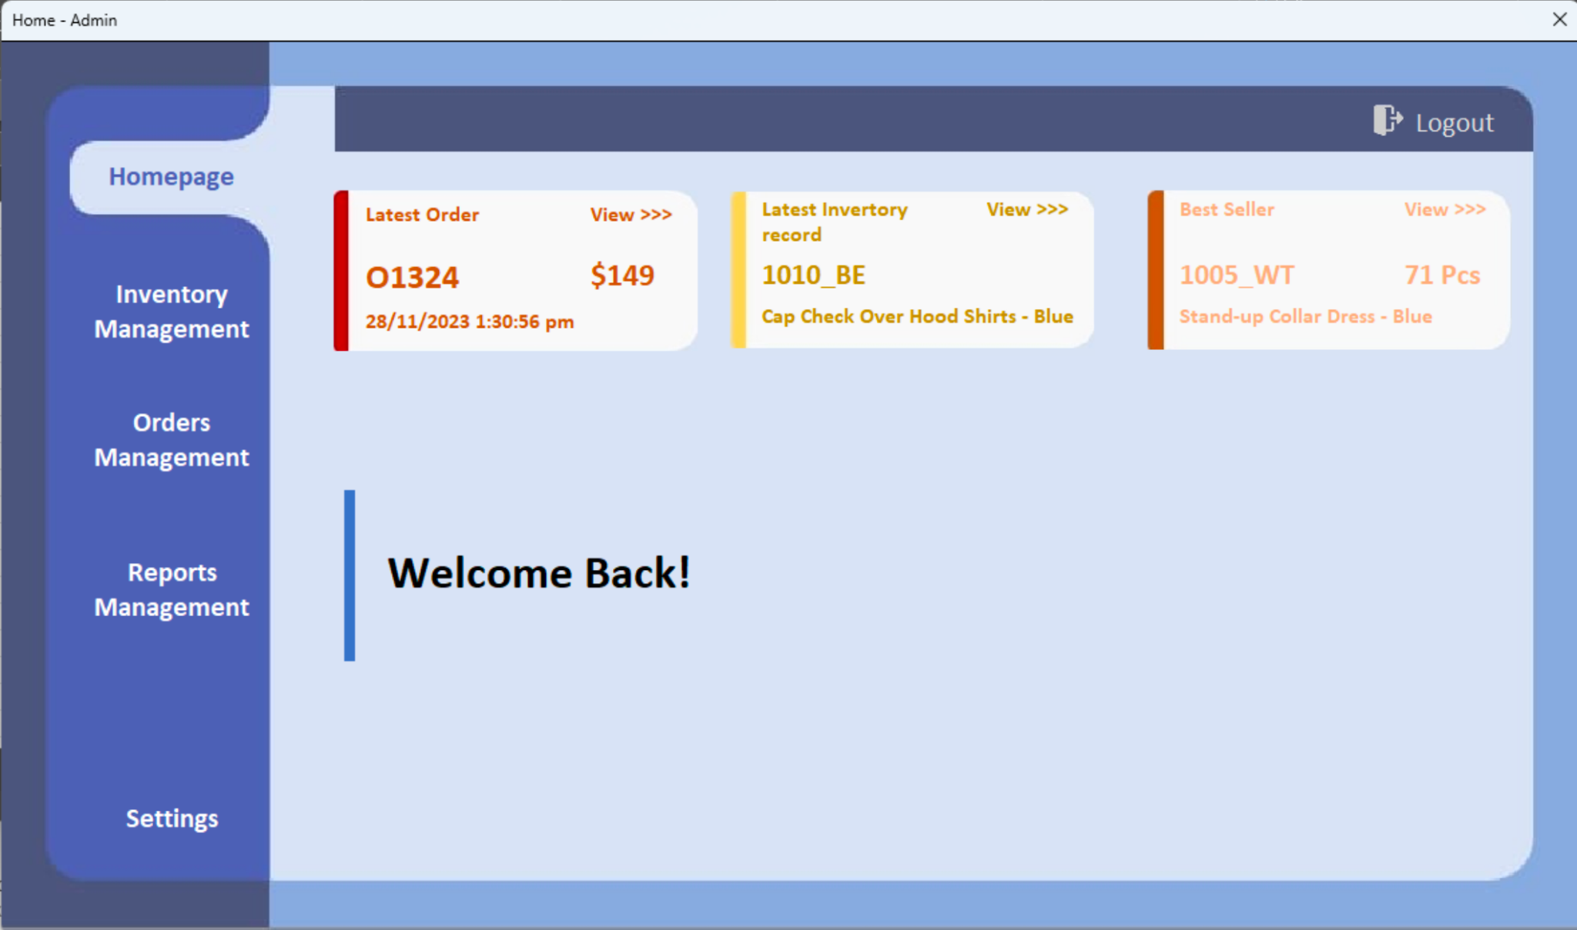

Figure 4.2a Admin Homepage User Interface

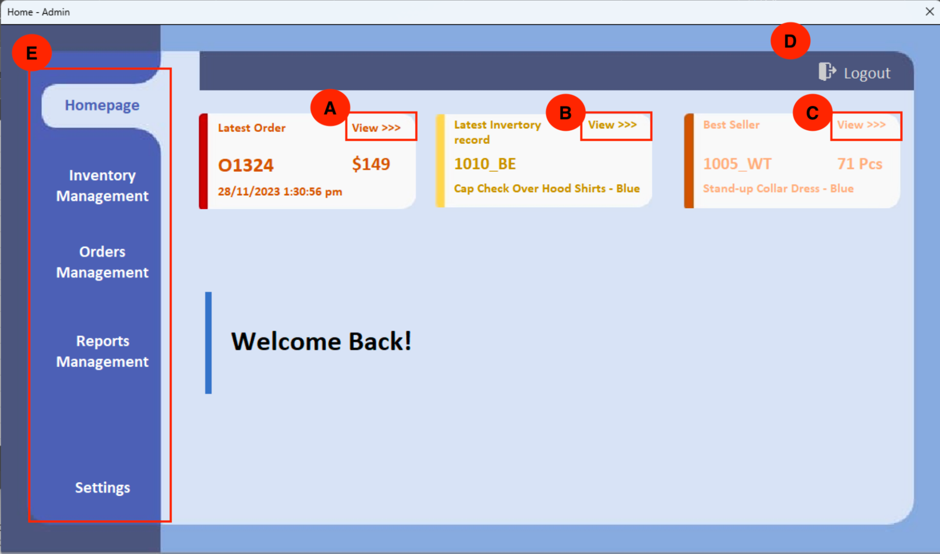

Figure 4.2b Admin Homepage Flow

* Part A shows the latest order section. Users can know more by clicking the “View >>>” text button. It will redirect to the Orders Management Page.
* Part B shows the latest inventory record section. Users can know more by clicking the “View >>>” text button. It will redirect to the Inventory Management Page.
* Part C shows the best seller section. Users can know more by clicking the “View >>>” text button. It will redirect to the Reports Management Page.
* Part D shows the ‘Logout’ button. Users can log out by clicking this button. It will redirect to the Index Page.
* Part E shows the navigation bar. Users are able to go to another page by clicking the different tab on the navbar.

## **4.3 Inventory Management**

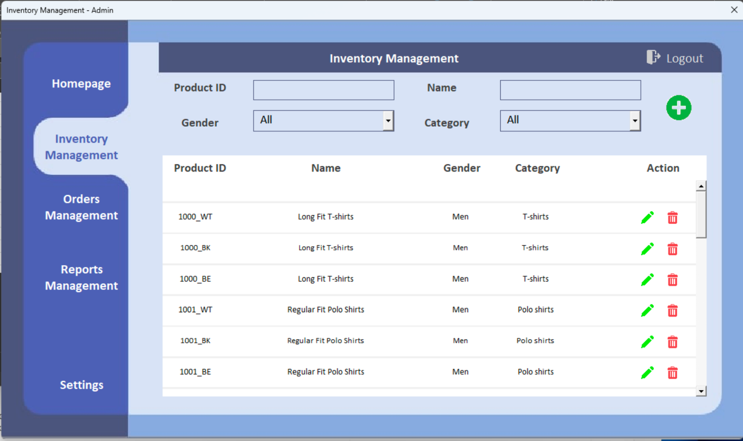

Figure 4.3a Inventory Management User Interface

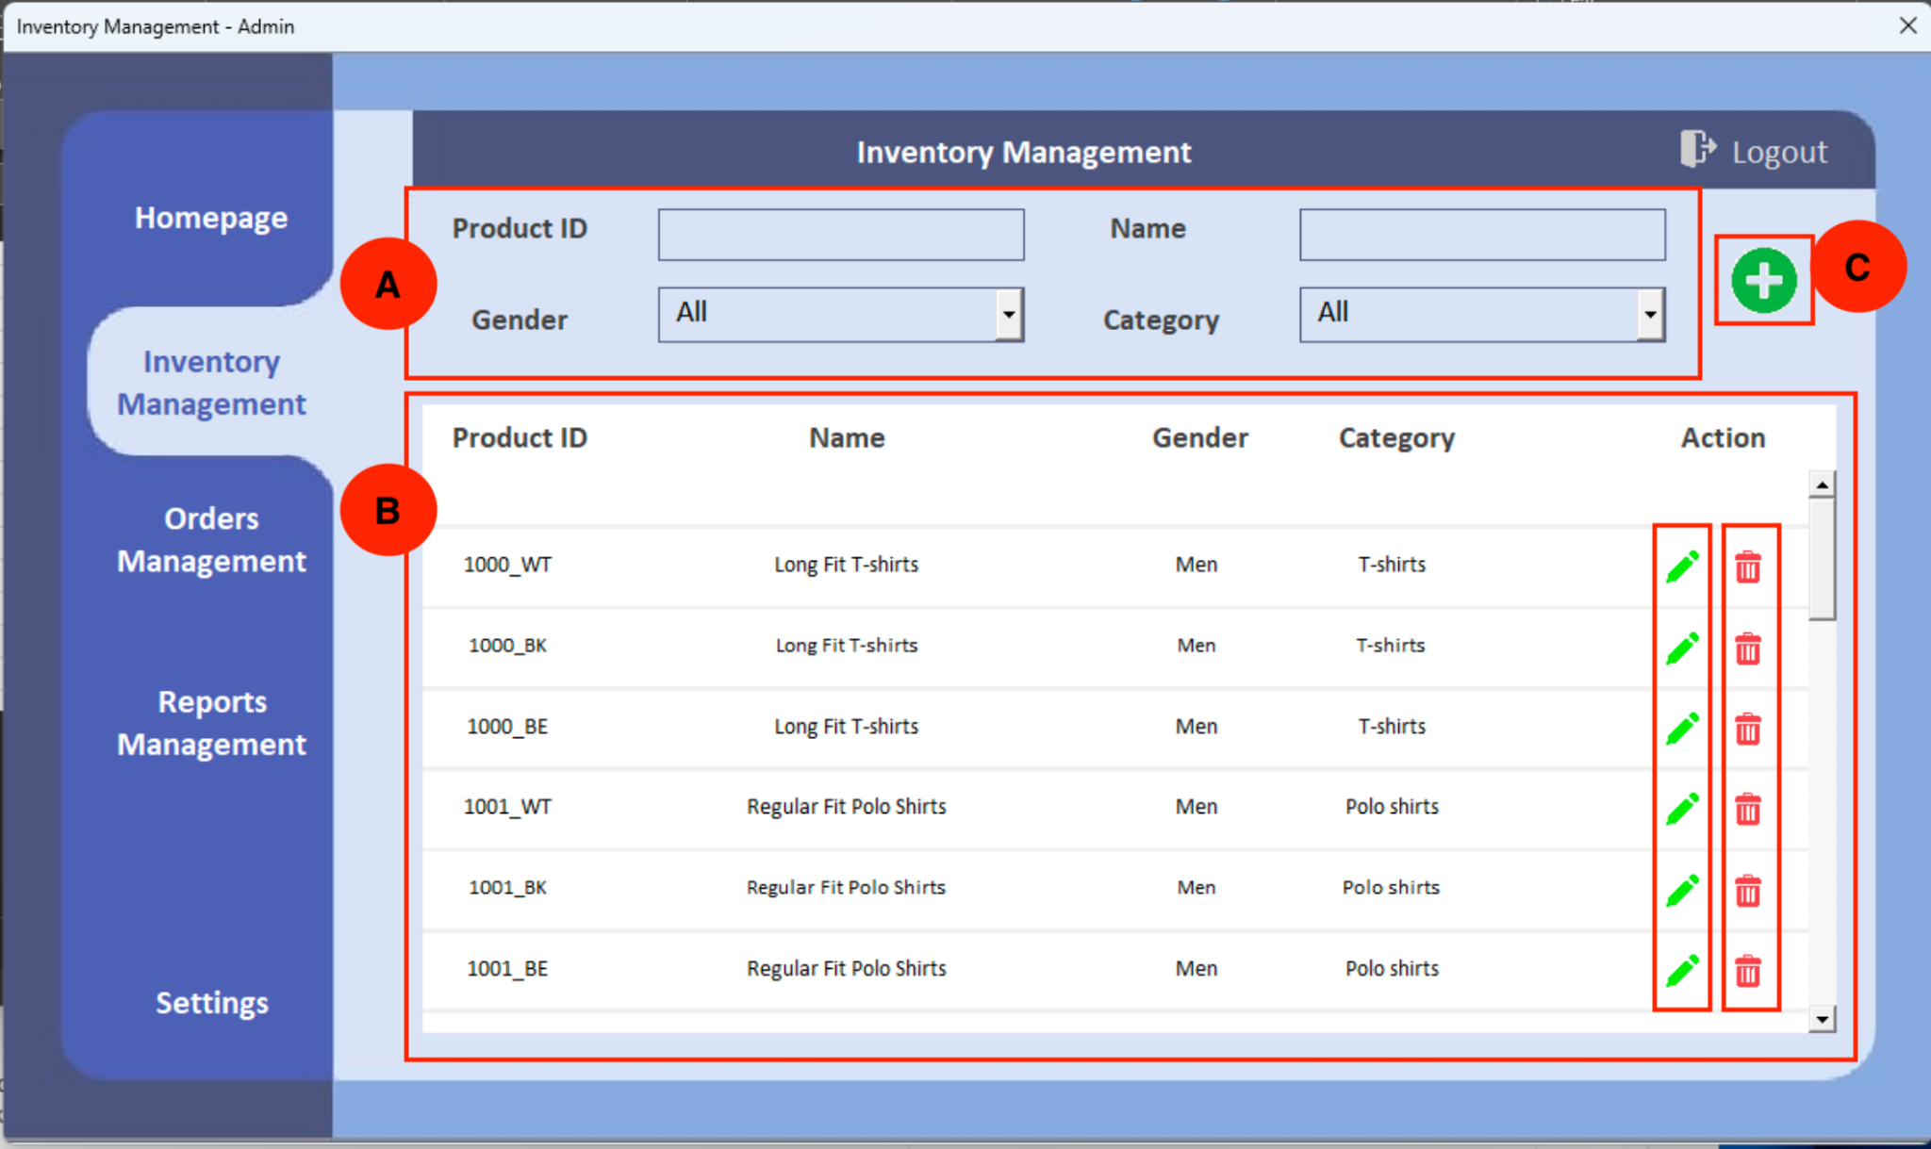

Figure 4.3b Inventory Management Flow

* Part A is the filter area. Users can filter the inventory records by inputting the Product ID, Name, Gender, and Category.
* Part B is the inventory table area. Users can view all the inventory records. If the user wants to edit the record, the user can click the green pen icon to edit. If the user wants to delete the inventory item, they can click the red trash icon.
* Part C is the add new product area. Users can add a new product by clicking the ‘+’ icon.

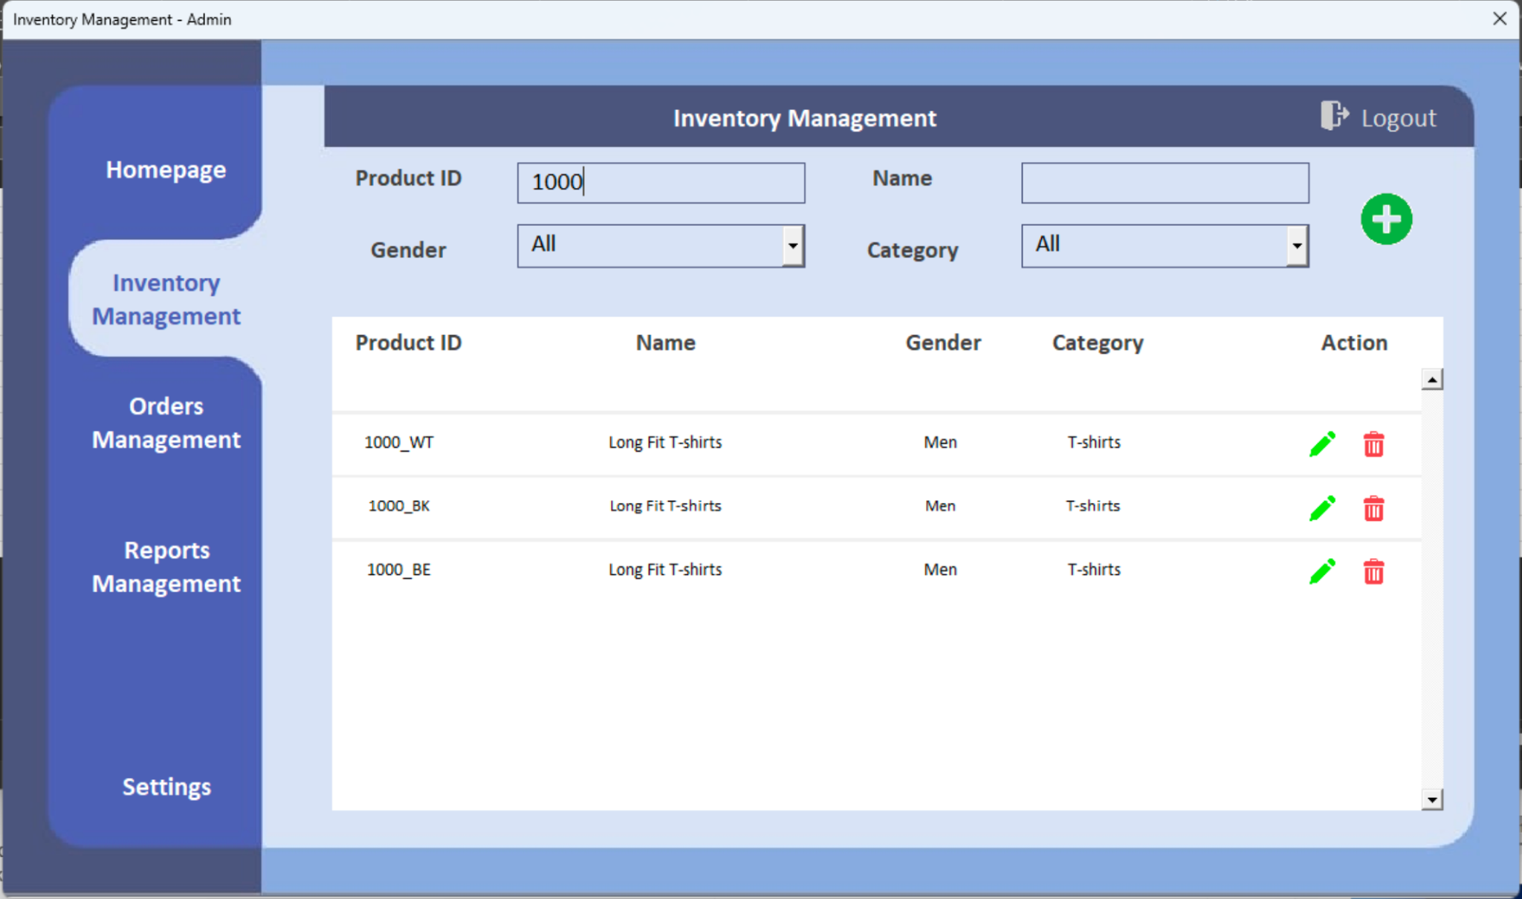

Figure 4.3c Inventory Filtered by Product ID

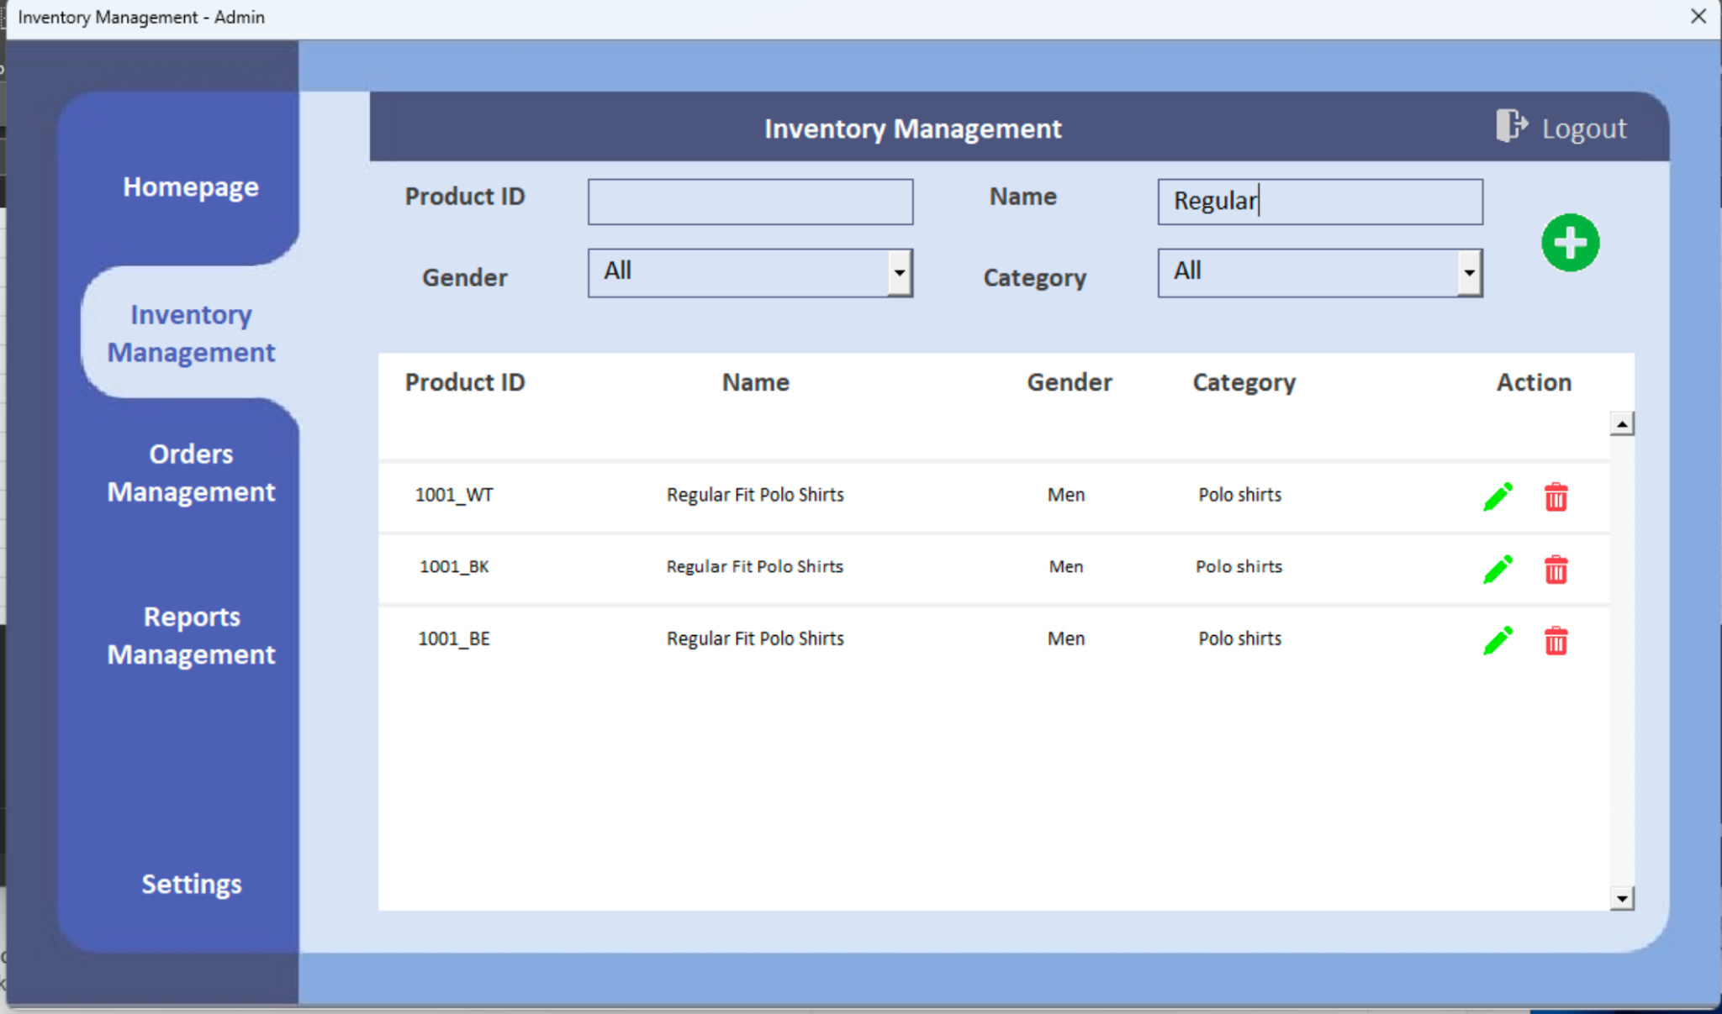

Figure 4.3d Inventory Filtered by Name

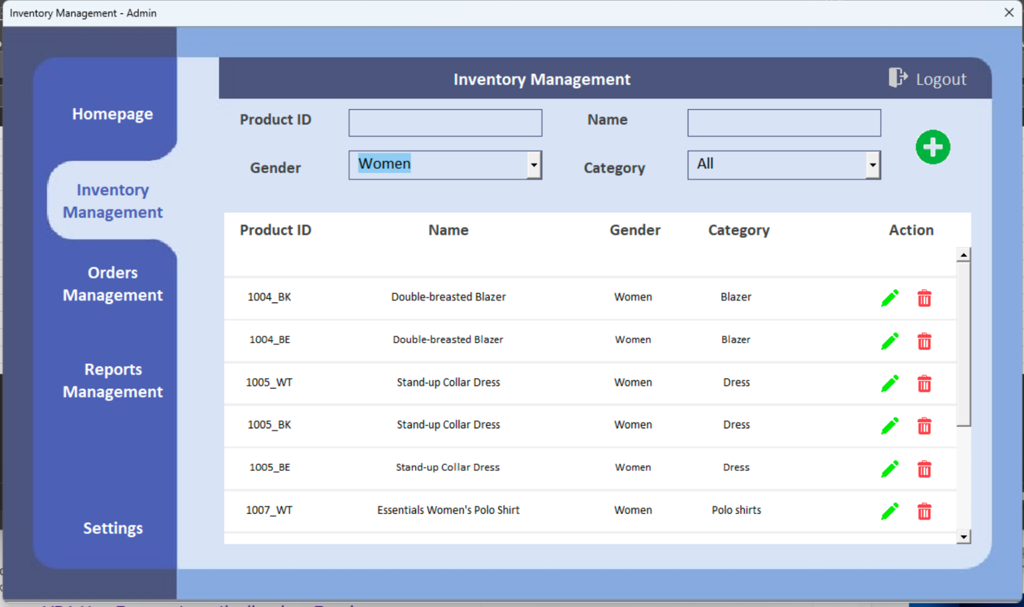

Figure 4.3e Inventory Filtered by Gender

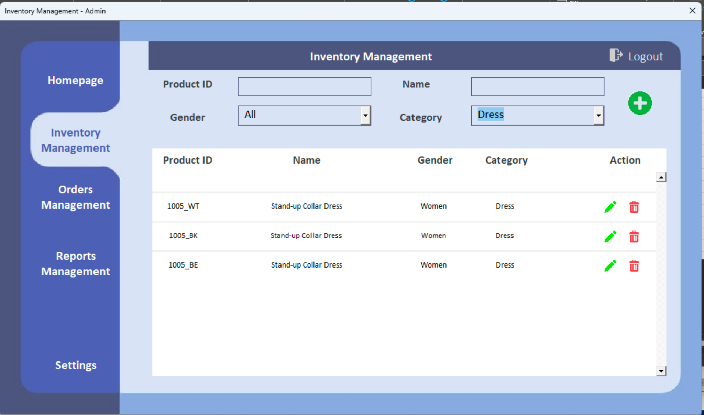

Figure 4.3f Inventory Filtered by Category

### 4.3.1 Add Product

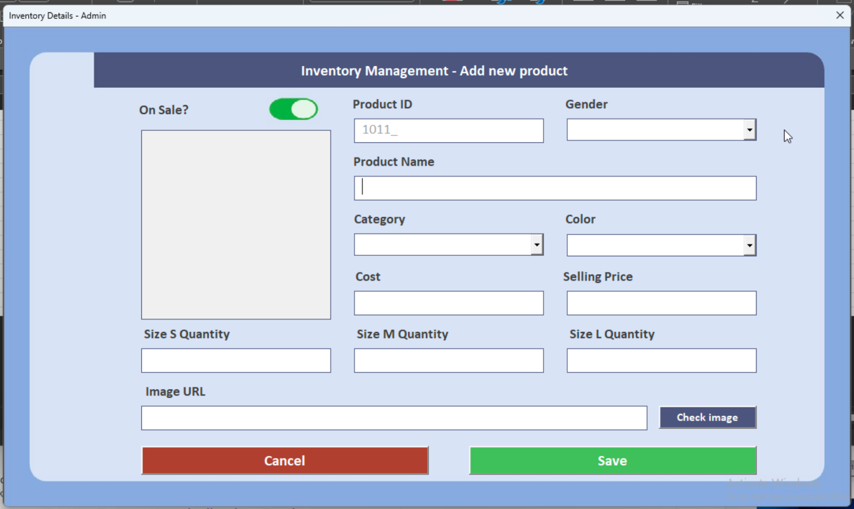

Figure 4.3.1a Inventory Management New Product Window

To add a product, users can click the ‘+’ icon and a new product window pops up.

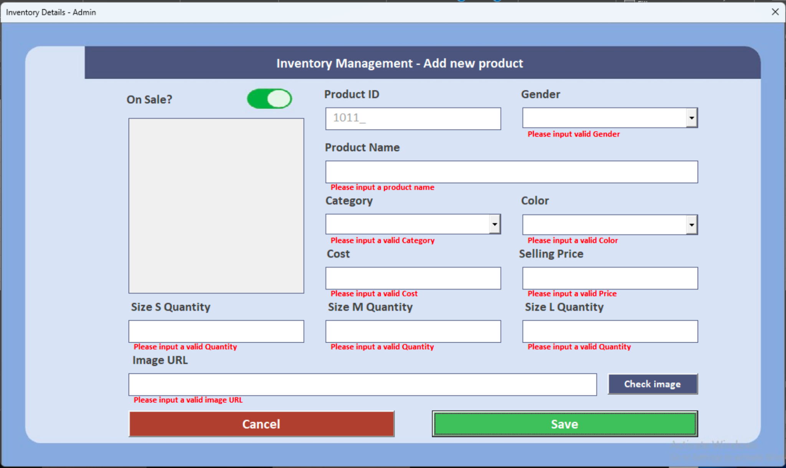

Figure 4.3.1b Inventory Management Error

Users need to input all the data to save the data. Or an error message will appear to alert the user.

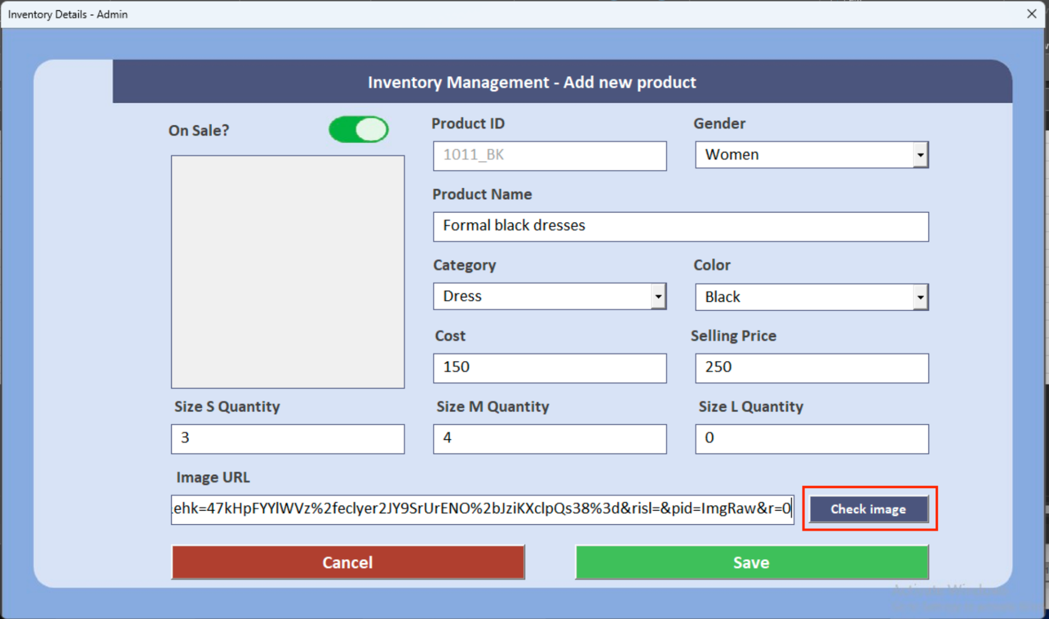

Figure 4.3.1c Check Image

After entering all the necessary data, the user can click ‘Check image’ button to check whether the input is a valid image URL.

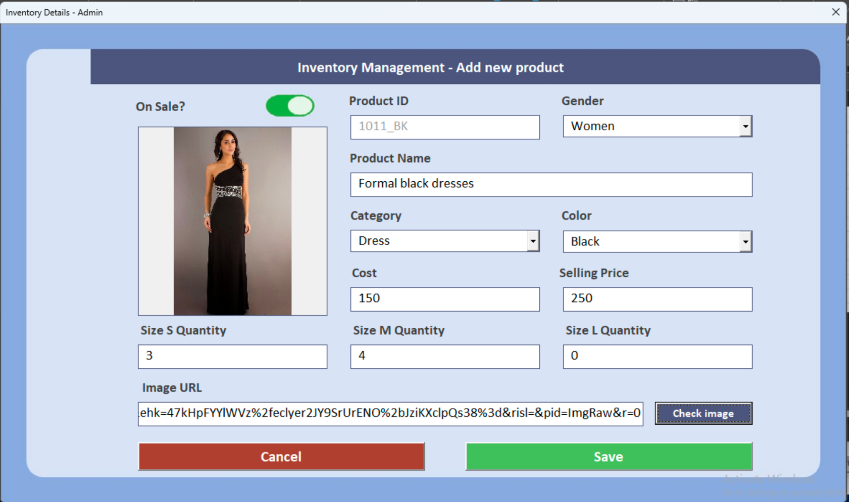

Figure 4.3.1d Inventory Management Image

If the URL is correct, the desired image will appear in the image box.

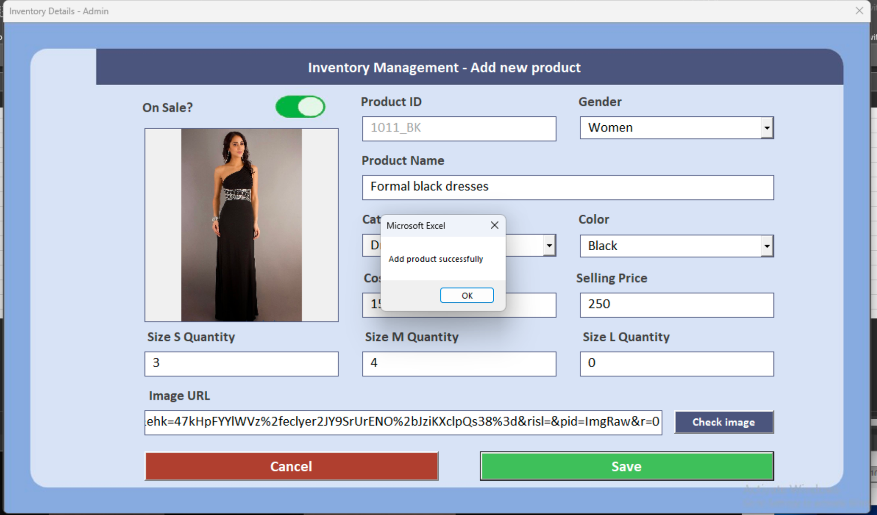

Figure 4.3.1e Inventory Management Save

The user can click the green ‘Save’ button to save the record. If saved successfully, a popup window will appear. If the user wants to go back to the Inventory Management Page, they can click the red ‘Cancel’ button.

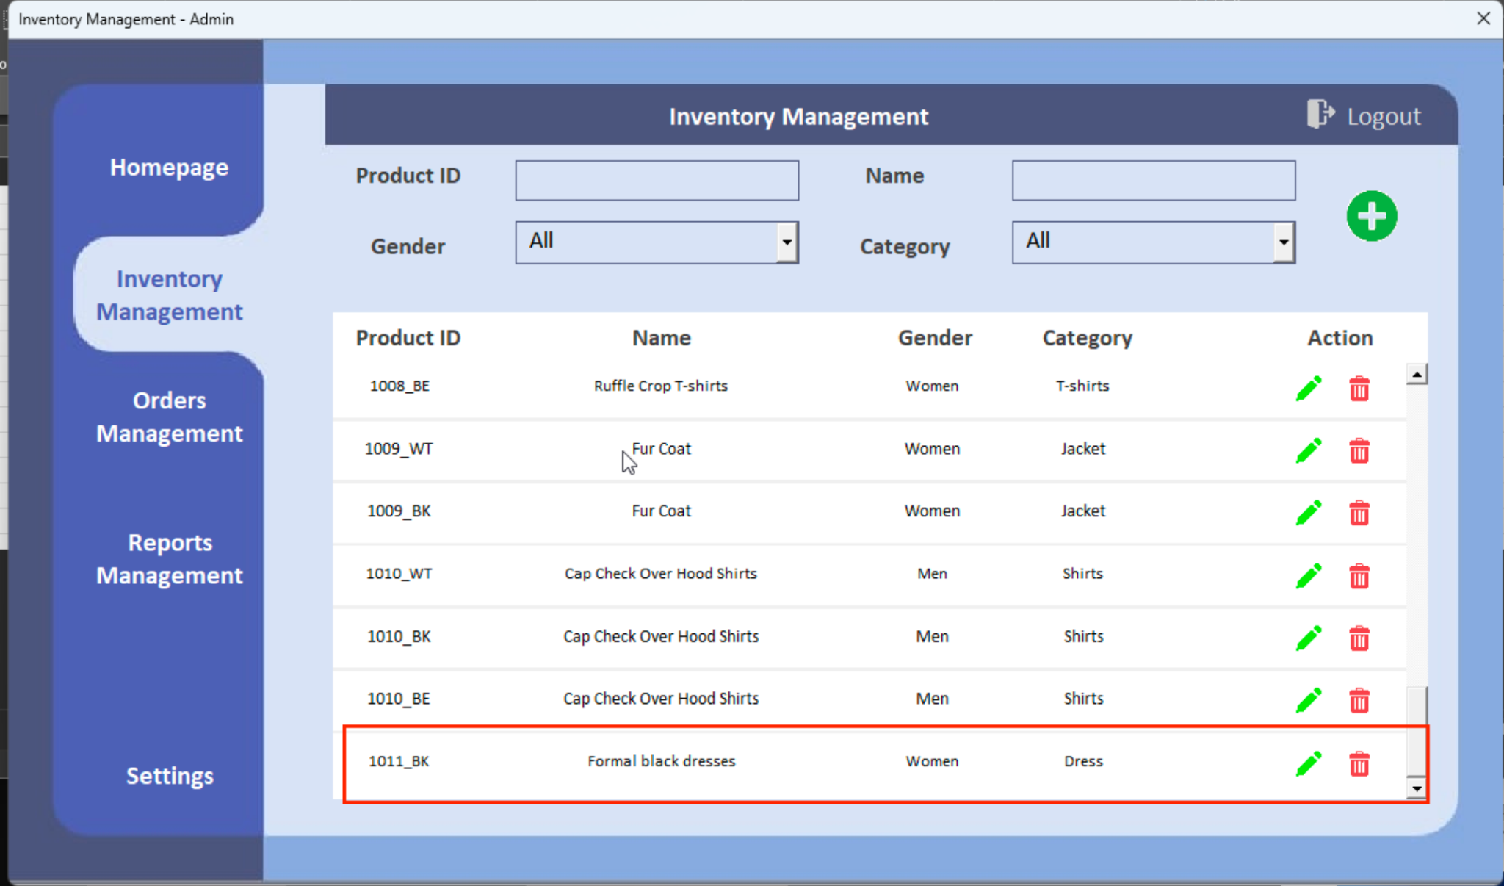

Figure 4.3.1f View New Inventory

The inventory table will automatically refresh so a newly added record is shown on the inventory table.

### 4.3.2 Edit Product

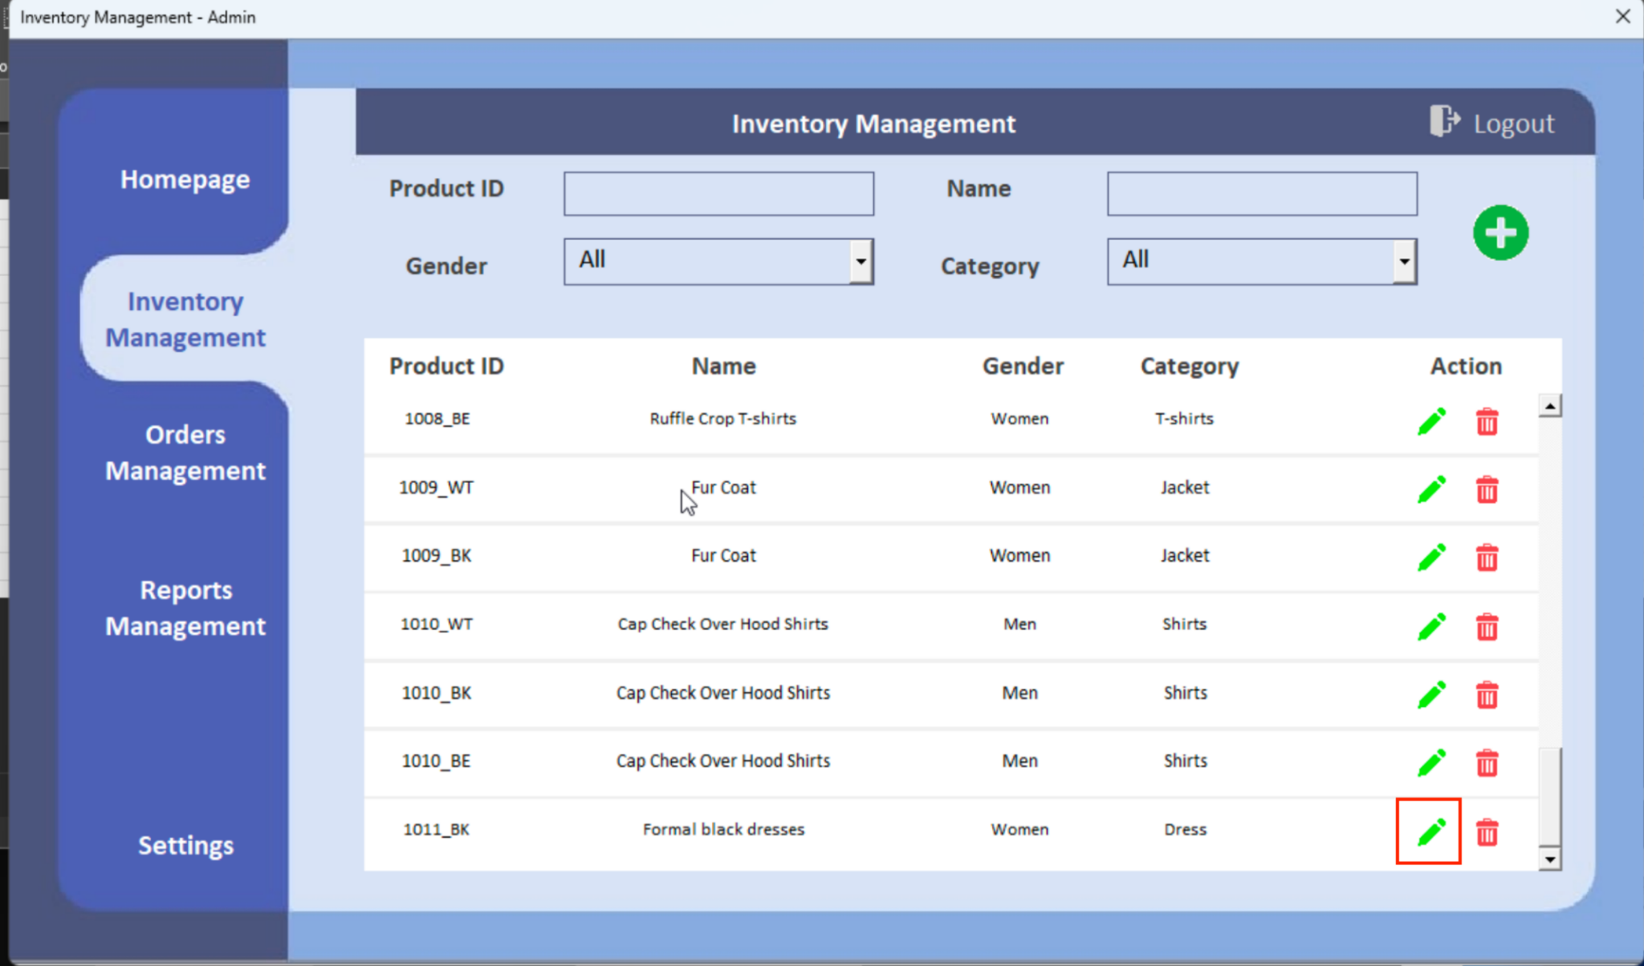

Figure 4.3.2a Edit Button Location

To edit a product existing in the inventory, the user must press the green ‘pen’ icon. The application will take the user to the new product window with the saved details.

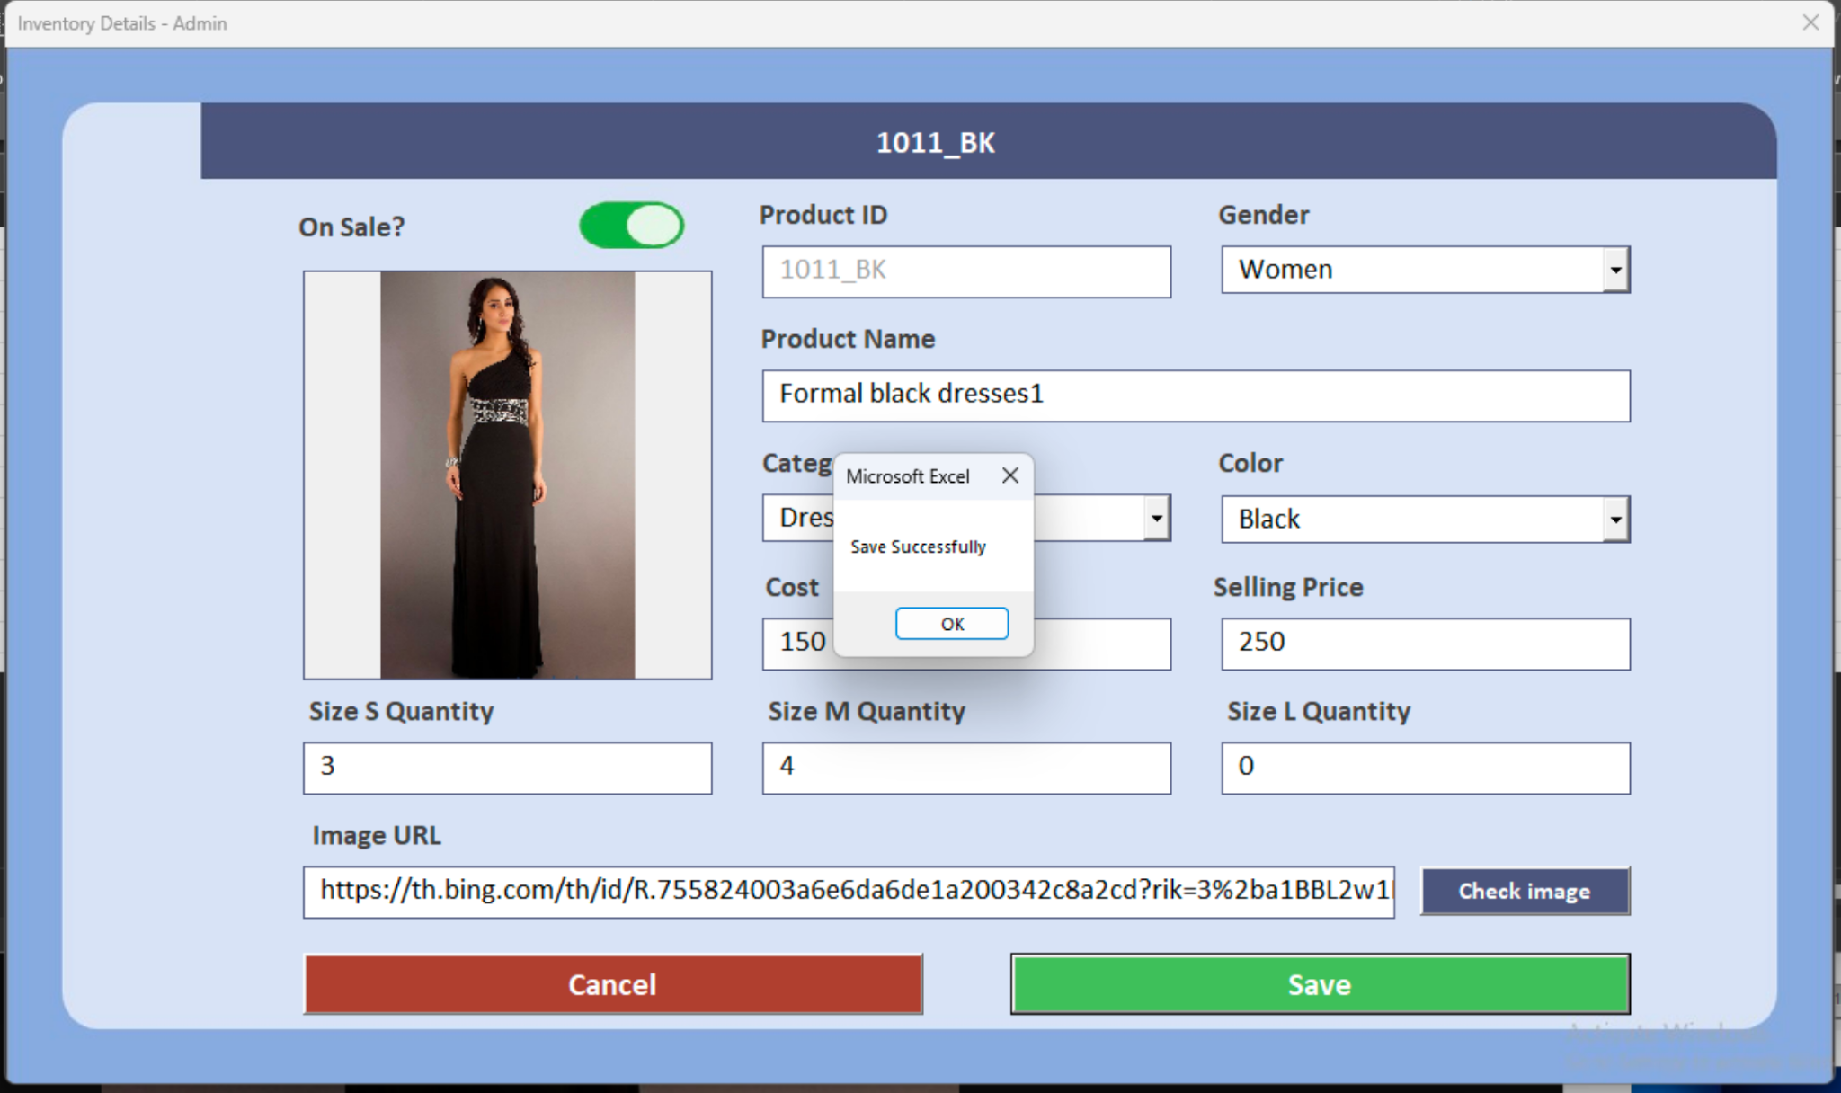

Figure 4.3.2b Edit Example

The admin can edit the details on the new product window. After editing, the user can click the green ‘Save’ button. The application will send the user back to the Inventory Management Page.

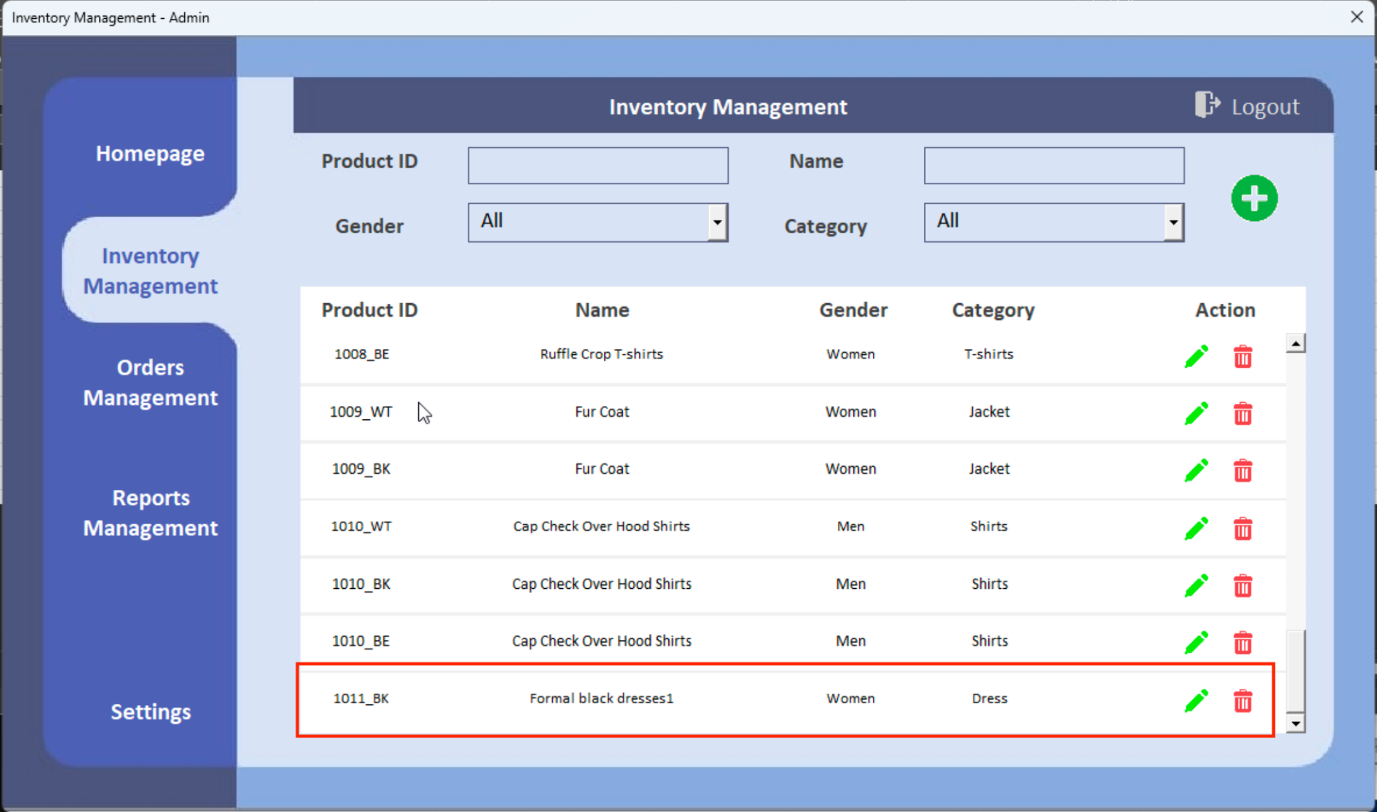

Figure 4.3.2b View New Edited Product

In the Inventory Management Page, the admin can view the new edited product on the list.

### 4.3.3 Delete Product

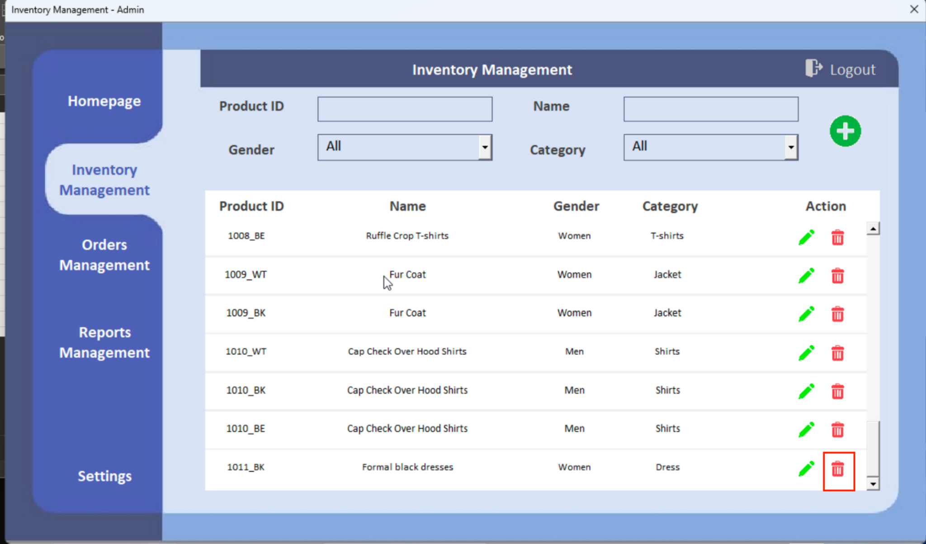

Figure 4.3.3a Trash Button Location

By clicking the red ‘trash’ icon, the user is able to delete the record.

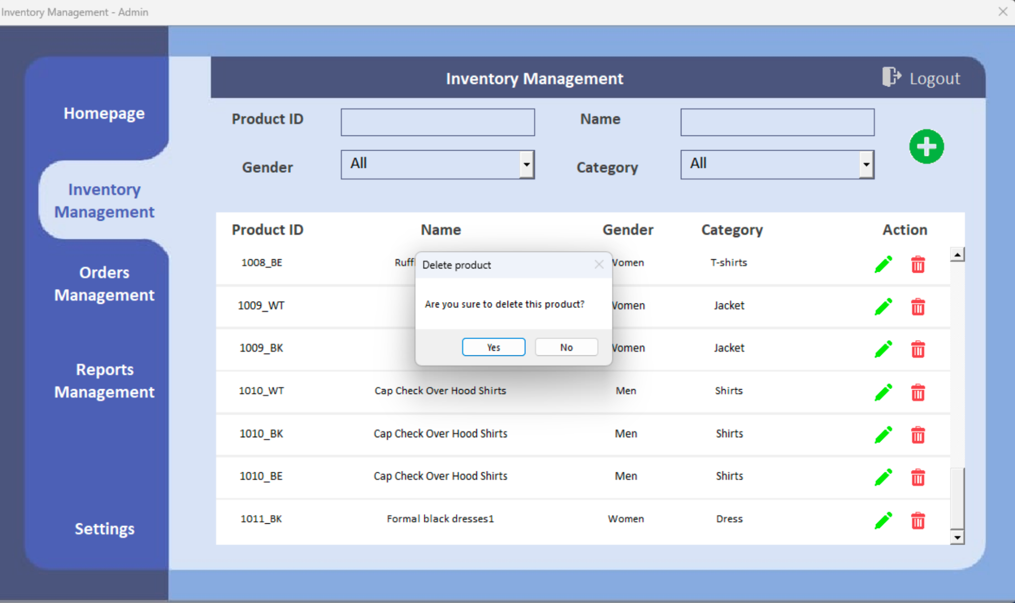

Figure 4.3.3a Confirmation Request Window for Delete

The popup window will ask you if you are confirmed to delete this item.

## **4.4 Orders Management**

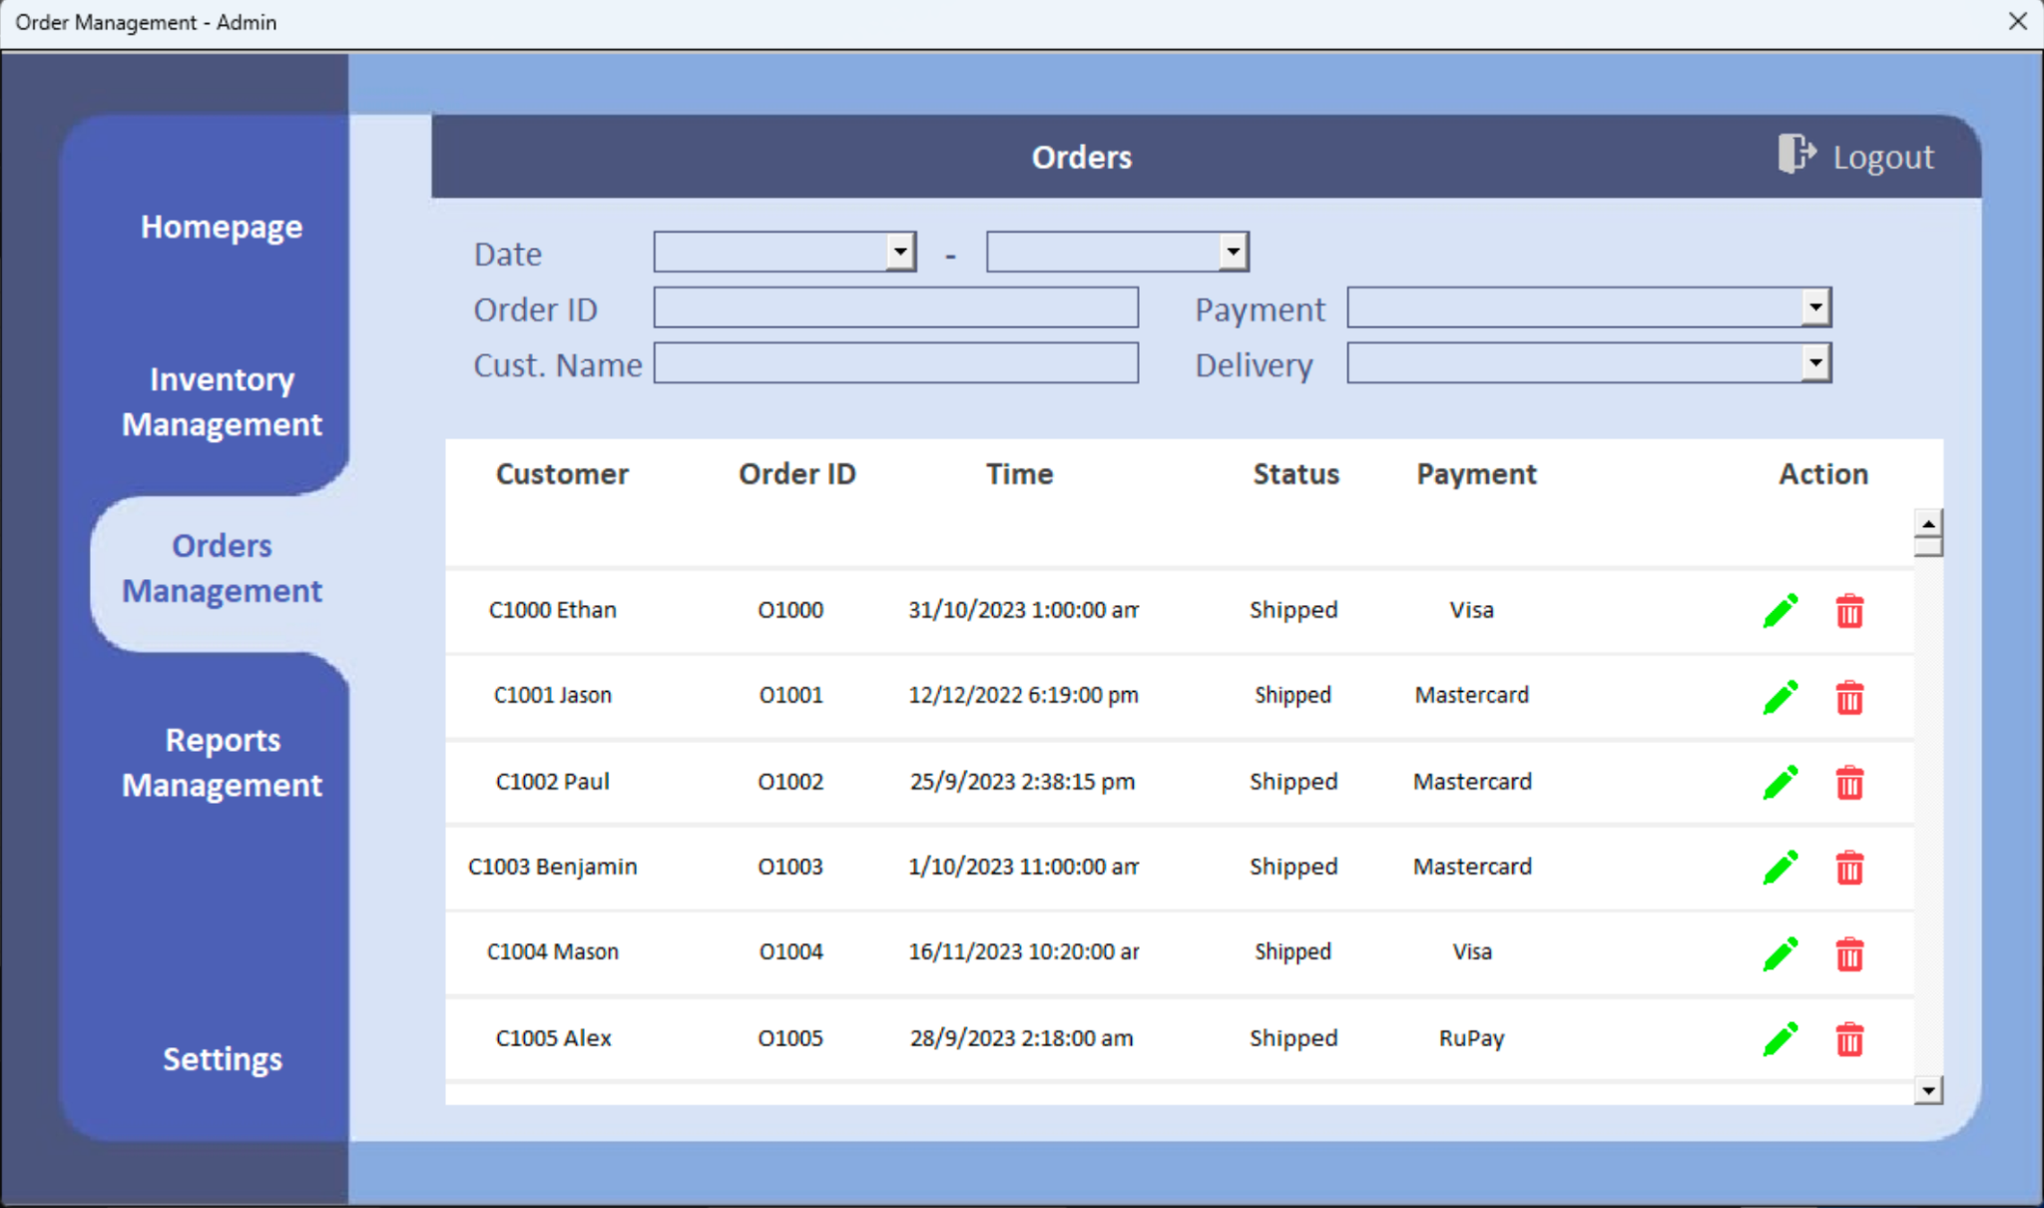

Figure 4.4a Orders Management User Interface

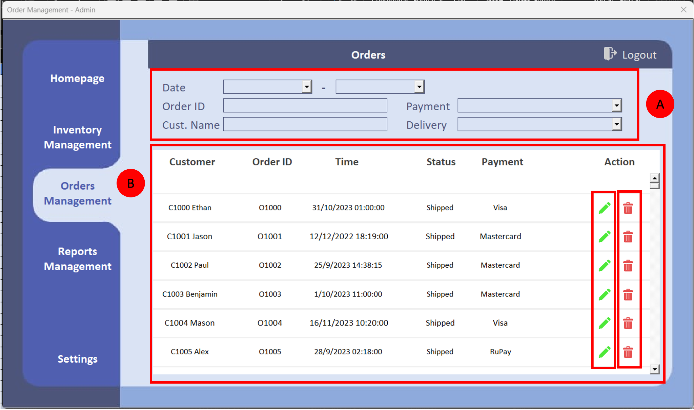

Figure 4.4b Orders Management Flow

* Part A area is the filter area. Users can filter the order records by inputting the Date, Order ID, Payment Method, Customer Name or Delivery Method.
* Part B area is the order table area. Users can view all the order records here. If the user wants to edit the order record, the user can click the ‘pen’ icon to edit. If the user wants to delete the order item, simply click the ‘trash’ icon to delete.

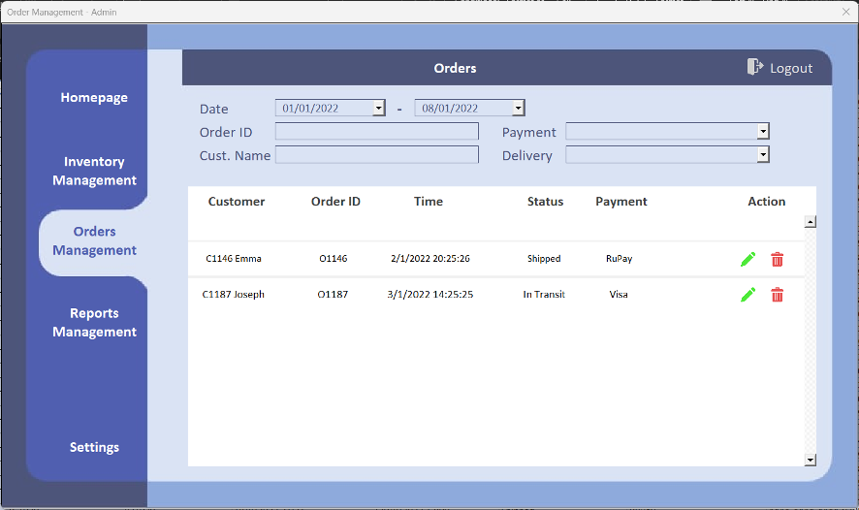

Figure 4.4c Orders Filtered by Date

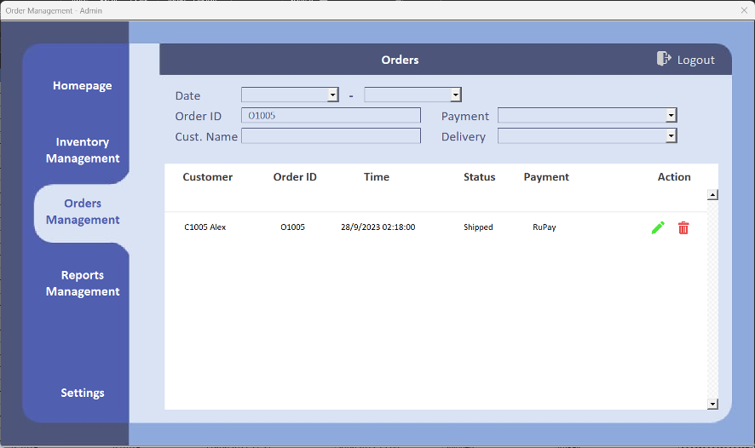

Figure 4.4d Orders Filtered by Order ID

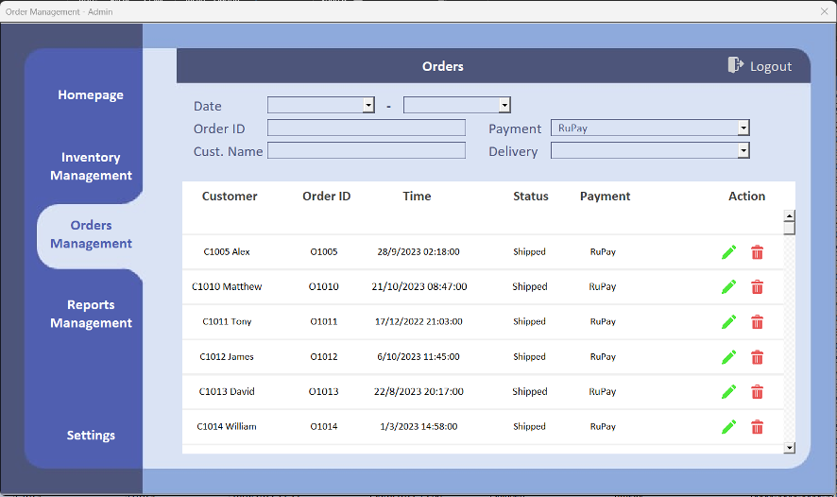

Figure 4.4e Orders Filtered by Payment

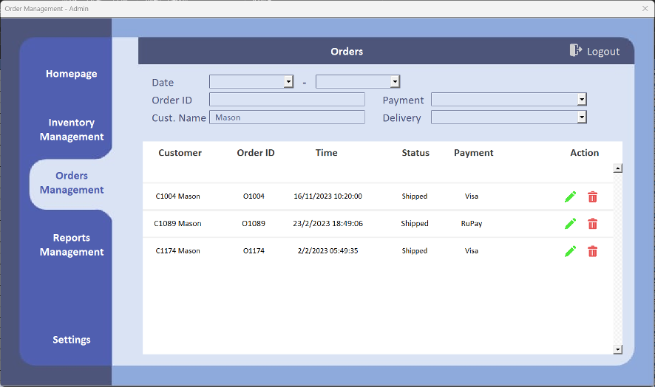

Figure 4.4f Orders Filtered by Customer Name

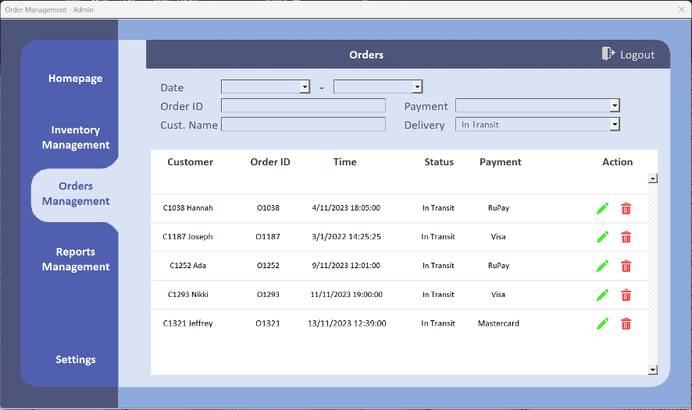

Figure 4.4f Orders Filtered by Delivery Method

## 

## 4.4.1 Edit Orders

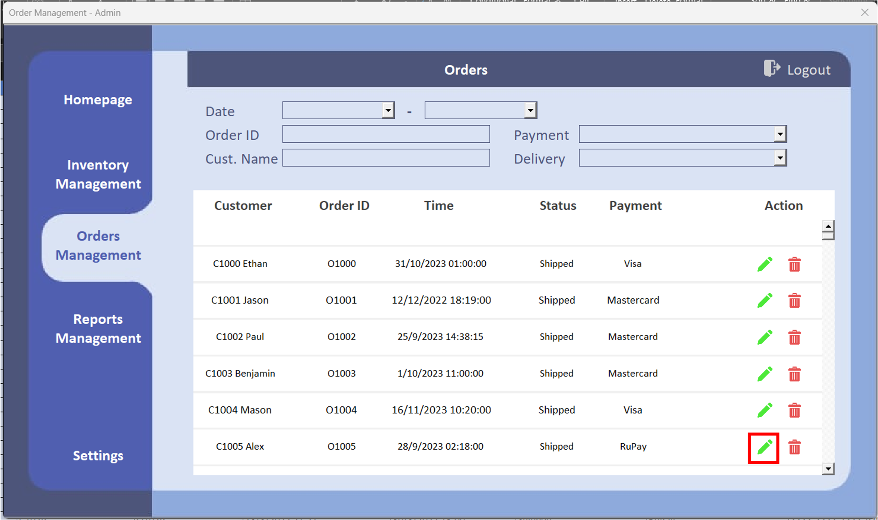

Figure 4.4.1a Orders Edit Location

By clicking the green ‘pen’ icon, the user is able to edit the order.

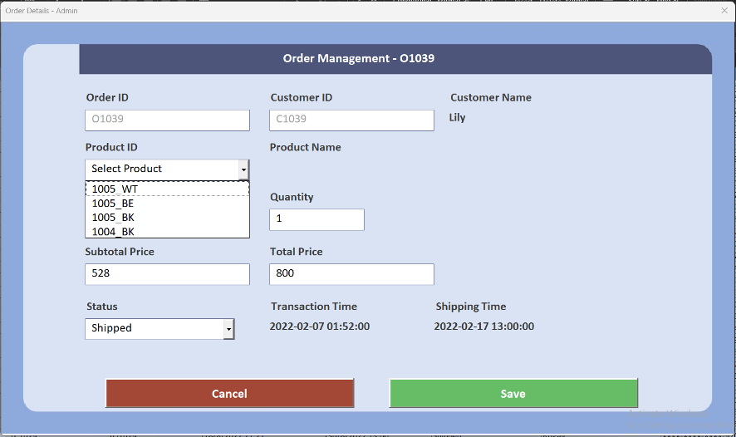

Figure 4.4.1b Edit Page

The user is required to select the products from the drop-down list in the Edit Page. The product, its subtotal price, and its quantity will be shown after selecting a product from the drop-down list. Furthermore, the user can check the transaction time and shipping time in the Edit page.

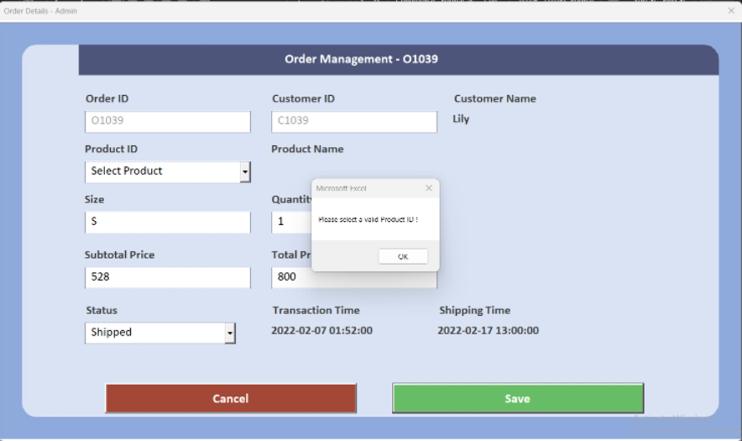

Figure 4.4.1c Invalid Product ID Prompt

If the user did not select a product and clicked ‘Save’, a prompt will be shown for the user to select a product before saving.

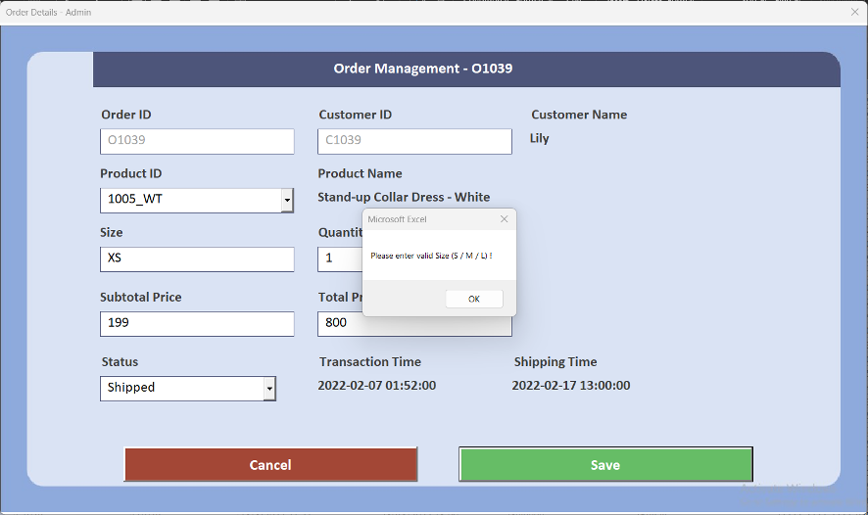

Figure 4.4.1d Invalid Size Prompt

If the user entered an invalid size of the product or did not enter the ‘Size’ field, a prompt will be shown for the user to input the correct product size.

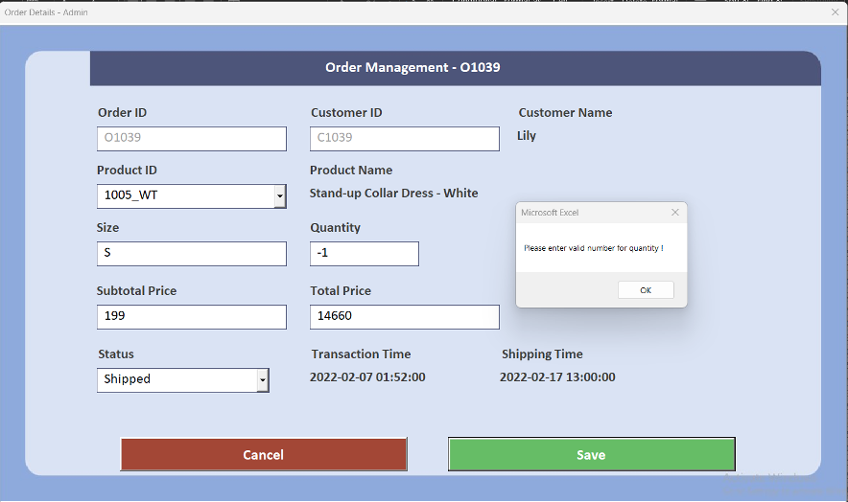

Figure 4.4.1e Invalid Quantity Prompt

If the user entered an invalid quantity of the product or did not enter the ‘Quantity’ field, a prompt will be shown for the user to input the valid quantity number.

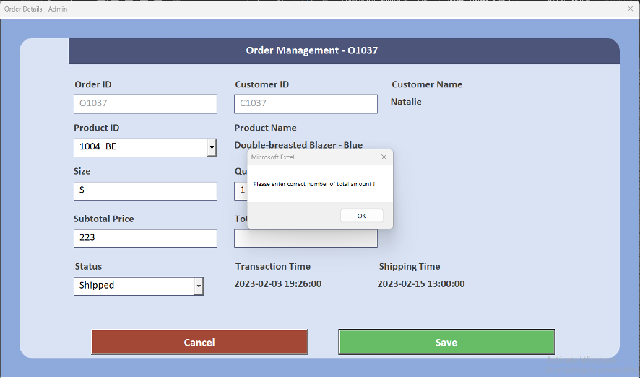

Figure 4.4.1f Invalid Price Prompt

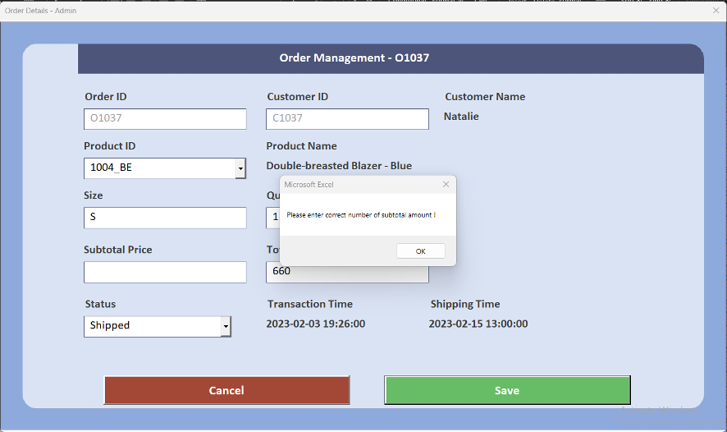

Figure 4.4.1e Invalid Subtotal Prompt

If the user entered invalid subtotal price / total price (e.g. -999, abcdefg) or did not enter the Subtotal Price / Total Price field, a prompt will be shown for the user to input a valid subtotal amount / total amount.

## 4.4.2 Delete Orders

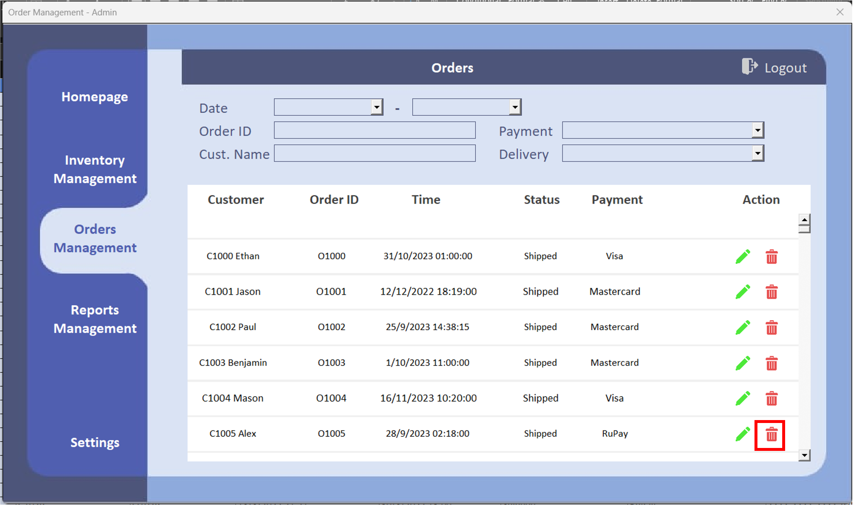

Figure 4.4.2a Orders Trash Icon Location

By clicking the red ‘trash’ icon, the order can be deleted from the order table.

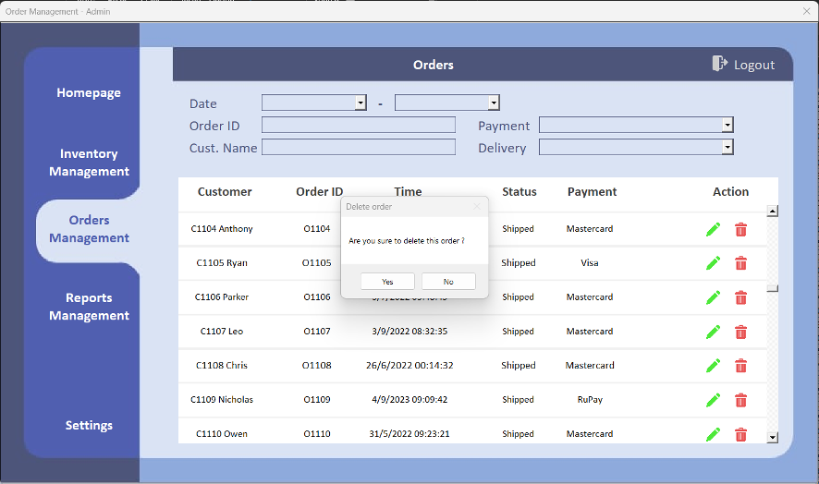

Figure 4.4.2a Delete Prompt

The user will be prompted to confirm deletion of the order item.

## **4.5 Reports Management**

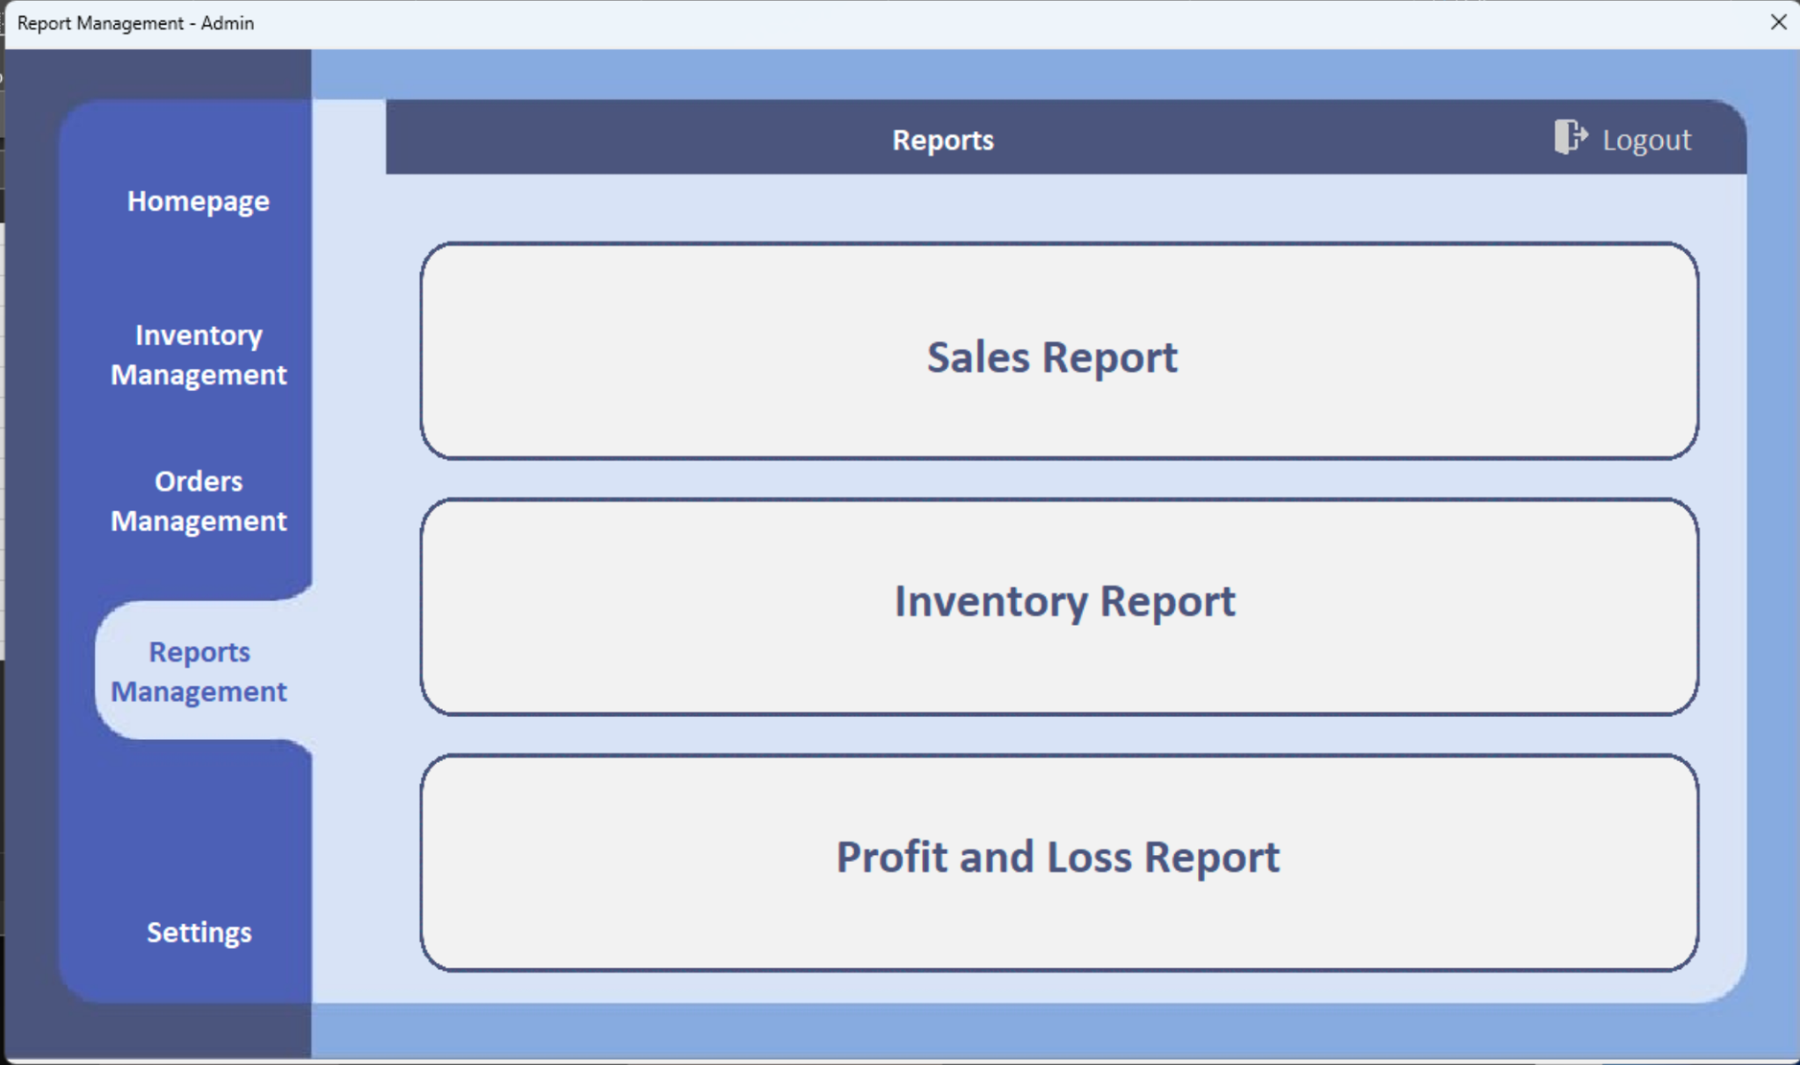

Figure 4.5 Reports Management User Interface

The menu of Reports Management is shown for the user to select the desired report between Sales Report, Inventory Report, and Profit and Loss Report.

*4.5.1 Sales Report*

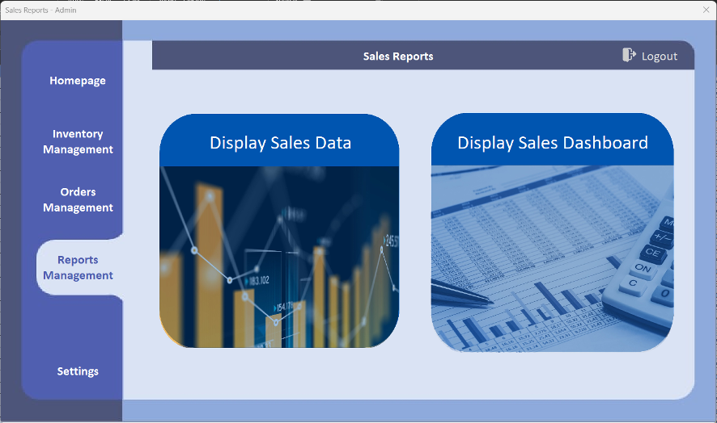

Figure 4.5.1.1a Sales Report User Interface

The menu of Sales Report is shown for the user to select either ‘Sales Data’ or ‘Sales Dashboard’.

*4.5.1.1 Sales Data*

There are three charts in Sales Data for showing the sales amount, which are divided into Years, Months (2022) and Months (2023). The user can select the charts by using the drop-down list at the top right corner.

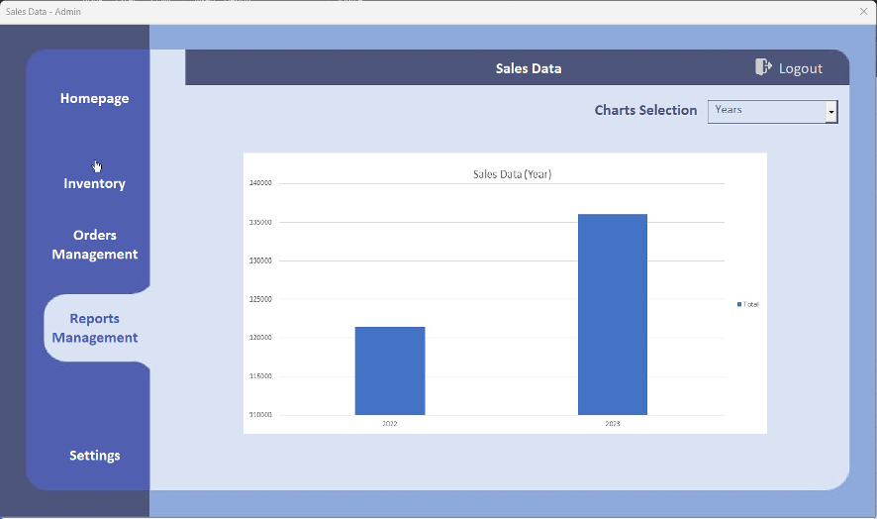

Figure 4.5.1.1.a Sales Data (Year)

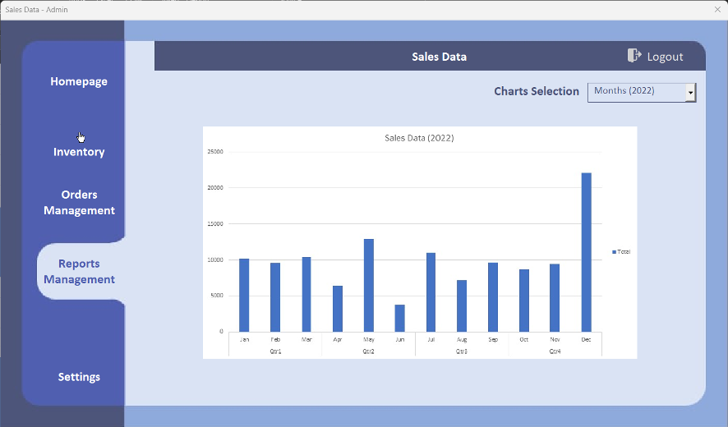

Figure 4.5.1.1b Sales Data (2022)

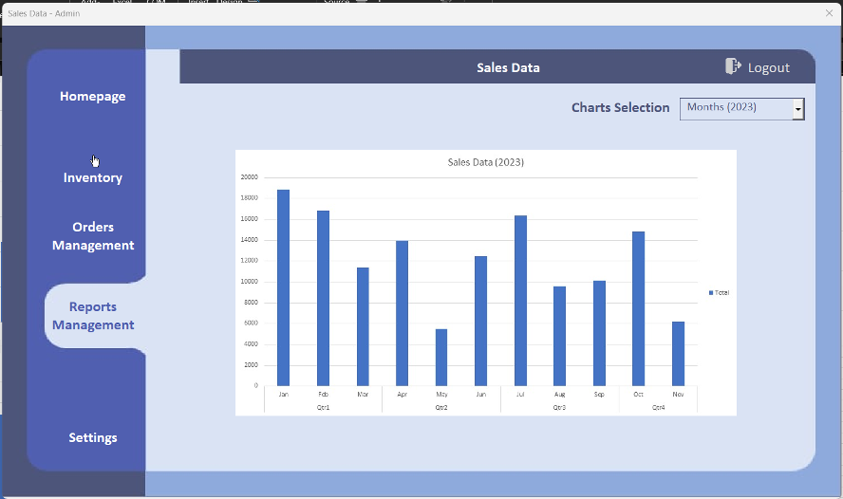

Figure 4.5.1.1c Sales Data (2023)

*4.5.1.2 Sales Dashboard*

Sales Dashboard shows different kinds of charts for the user to analyze the sales data. The user can get insights from the charts to develop better sales strategies such as promotions and offers to enhance sales performance. The charts are divided into Category Sales, Sales by Size, Sales by Gender, Average Amount of Sales, and Payment Method Used. A drop-down box is provided for the user to select the relevant chart.

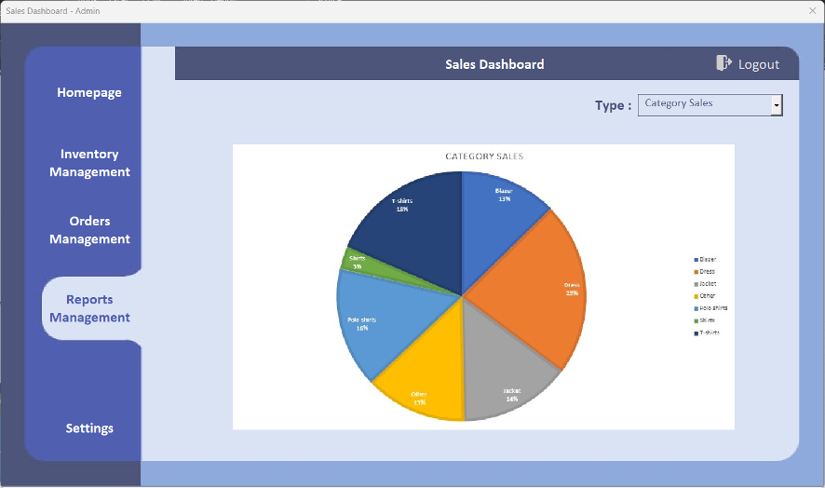

Figure 4.5.1.2a Sales Dashboard User Interface

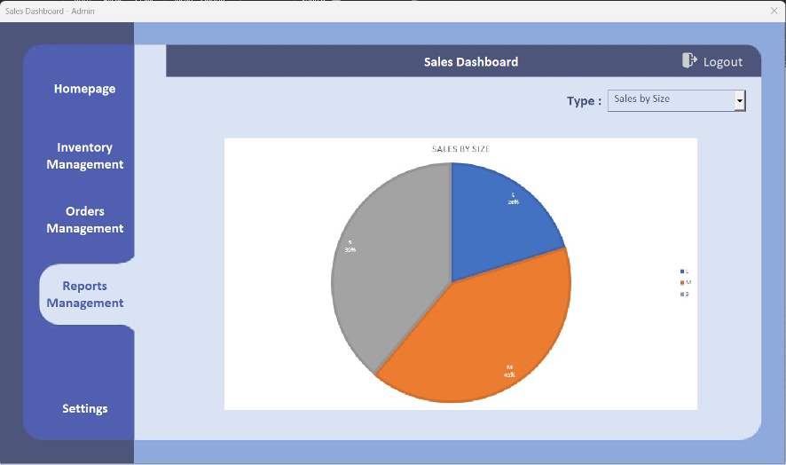

Figure 4.5.1.2b Sales By Size

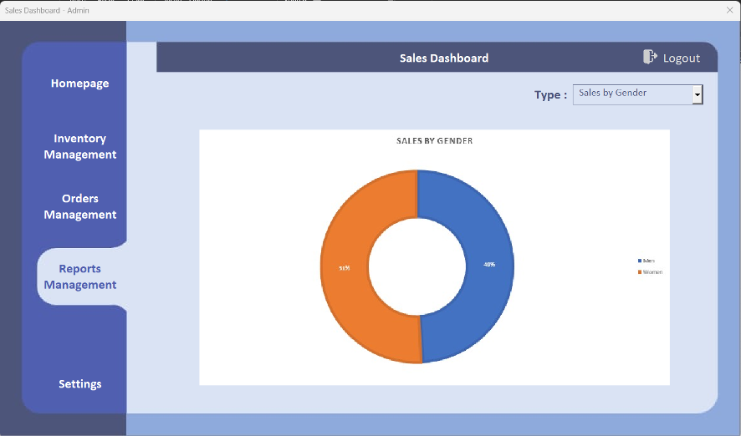

Figure 4.5.1.2c Sales By Gender

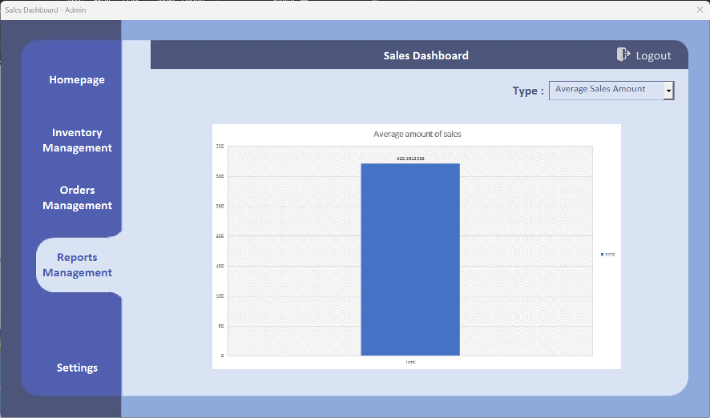

Figure 4.5.1.2d Average Sales Amount

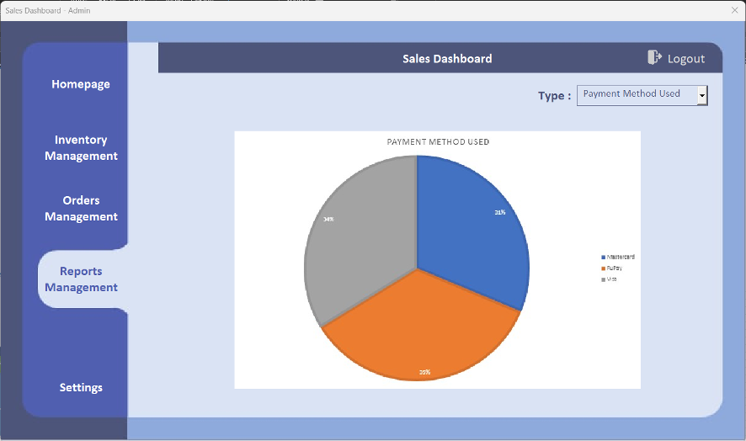

Figure 4.5.1.2e Payment Method Used

*4.5.2 Inventory Report*

The left upper drop-down button allows the user to choose “List All”, “Quantity Report”, and “Category Report”.

*4.5.2.1 List All*

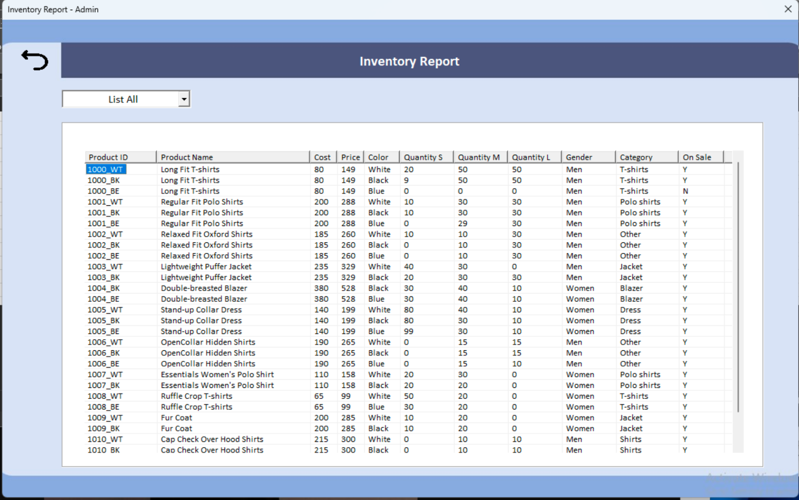

Figure 4.5.2.1 Full Inventory List

*4.5.2.2 Quantity Report*

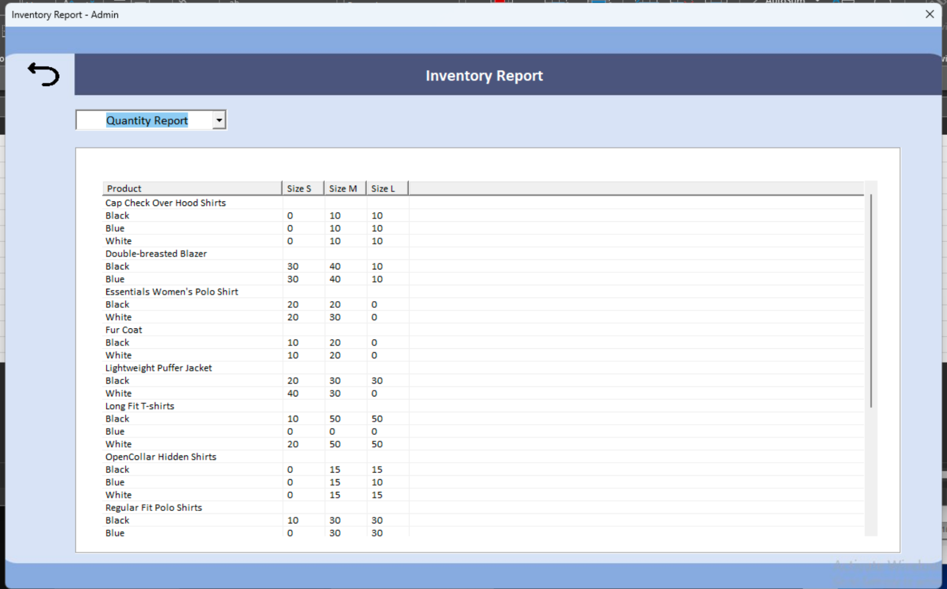

Figure 4.5.2.2 Quantity Report

*4.5.2.3 Category Report*

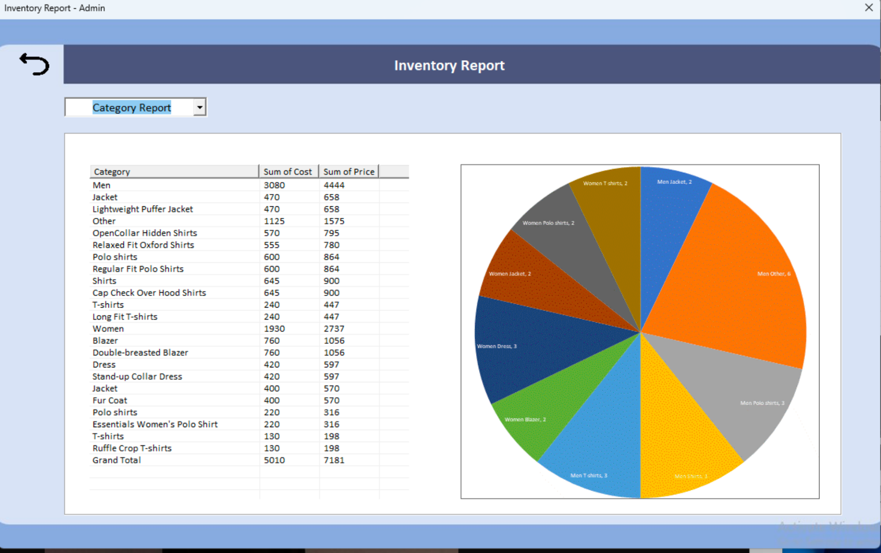

Figure 4.5.2.3 Category Report

*4.5.3 Profit and Loss Report*

The Profit and Loss Report displays whether the shop earns sufficient daily revenue.

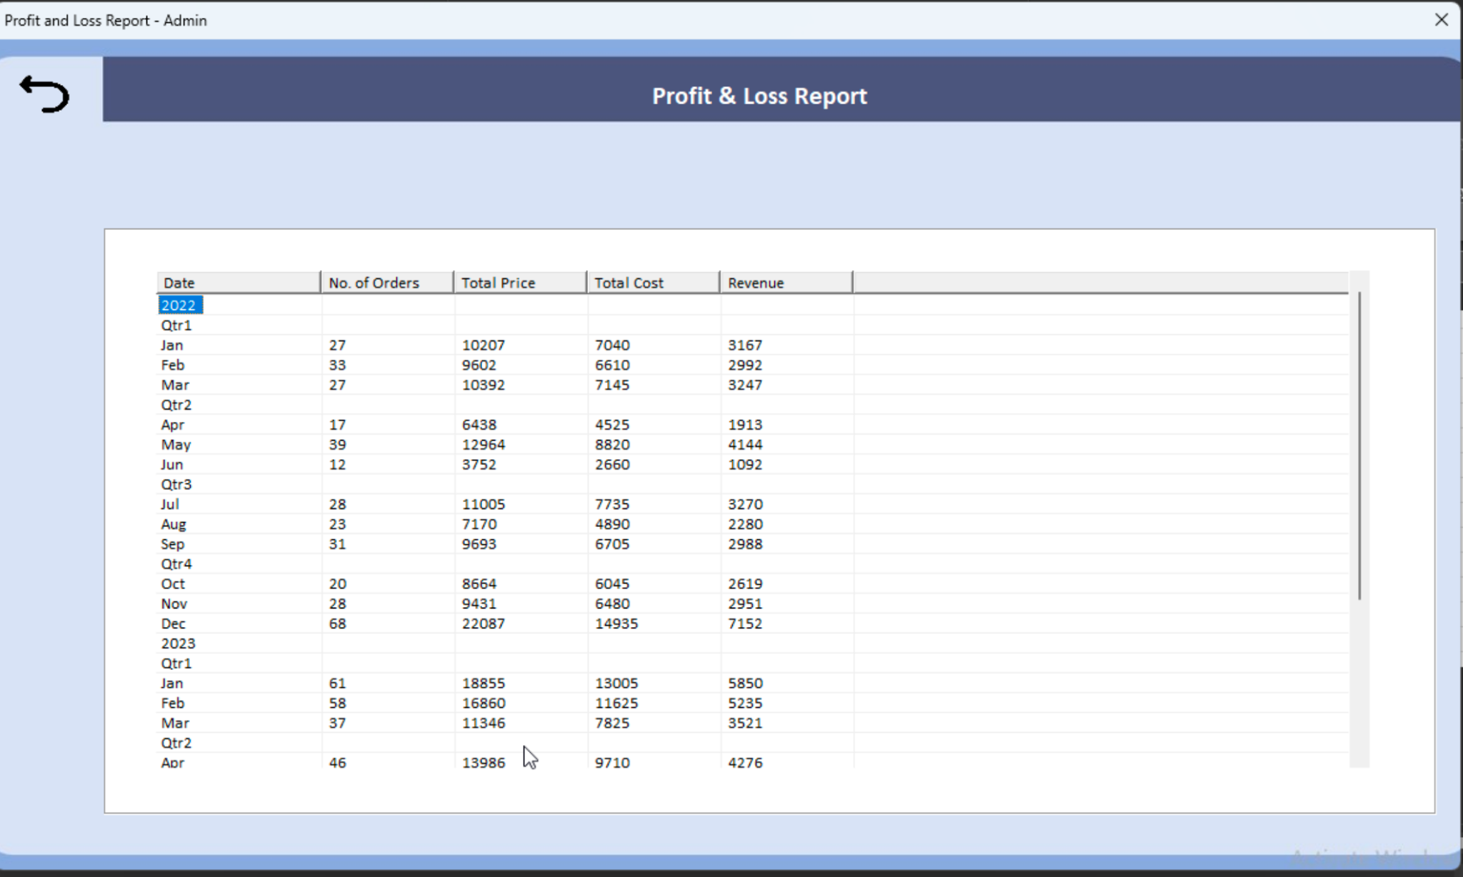

Figure 4.5.3 Profit and Loss Report

## **4.6 Settings**

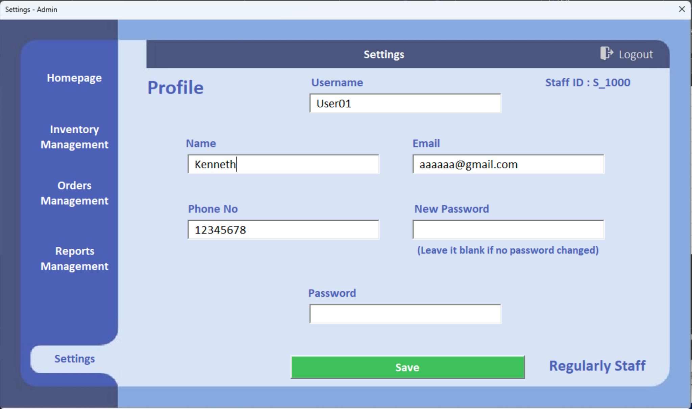

Figure 4.6a Settings User Interface

In ‘Settings’, staff can edit their personal information. Each time the staff wants to change their personal information, identity verification is required. The old password must be inputted to complete the verification.

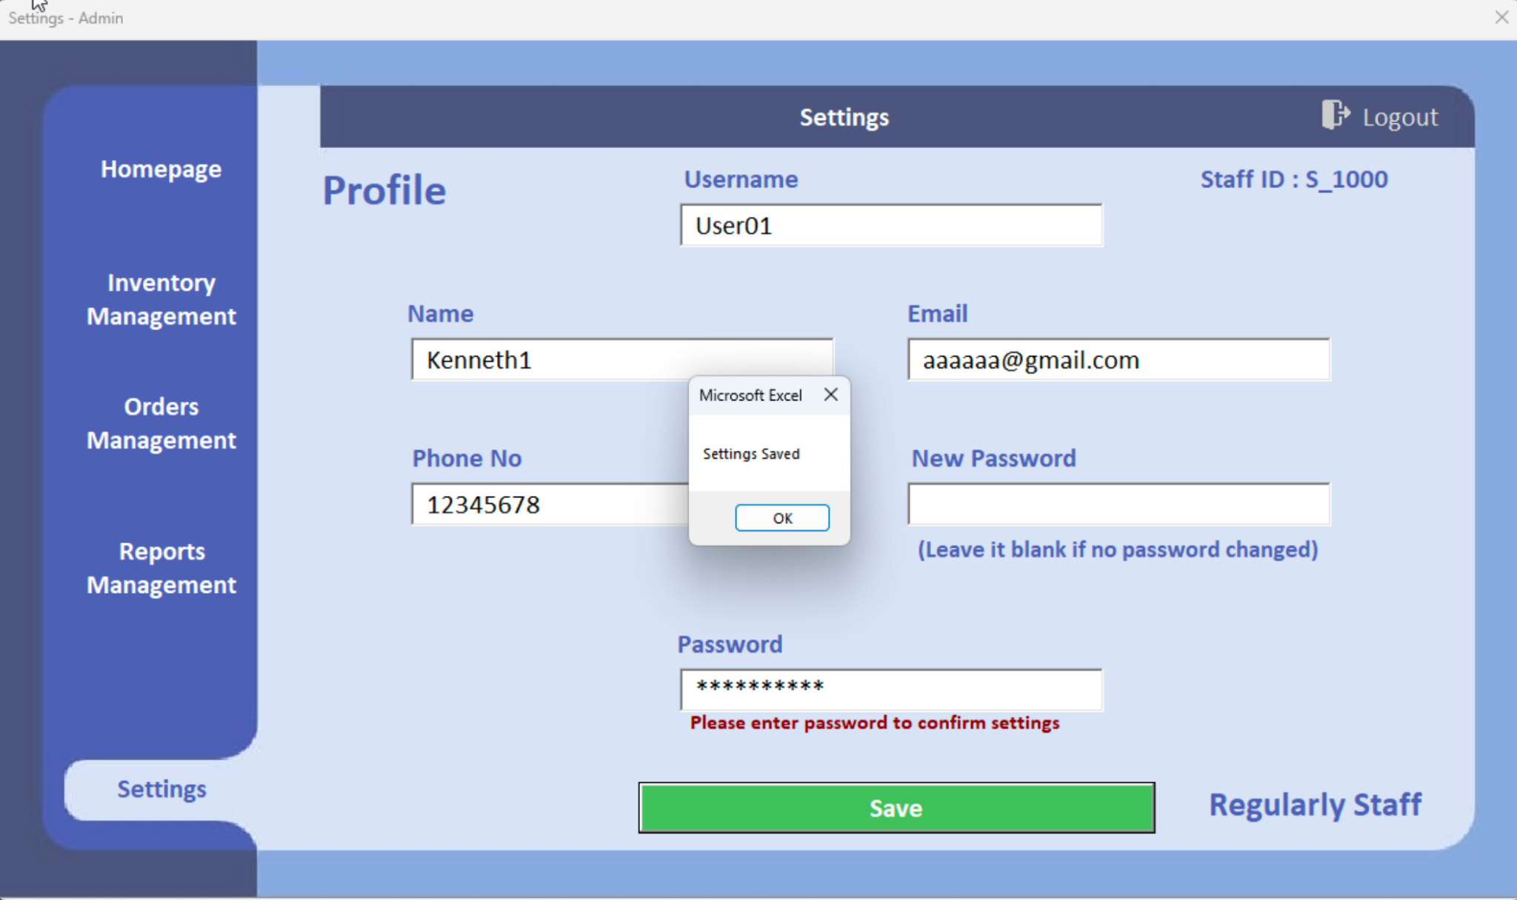

Figure 4.6b Successfully Change Personal Information

If successfully changed, a popup window appears.